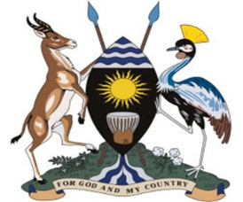
REPUBLIC OF UGANDA
OFFICE OF THE PRESIDENT
DIRECTORATE OF SOCIO-ECONOMIC MONITORING AND
RESEARCH
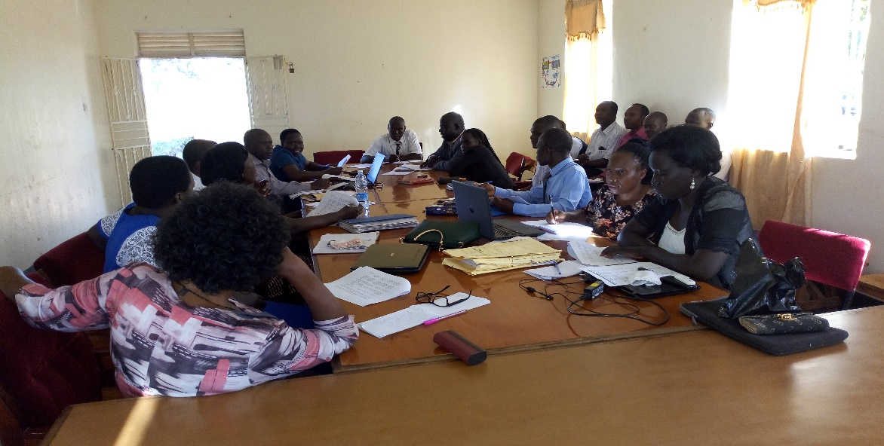
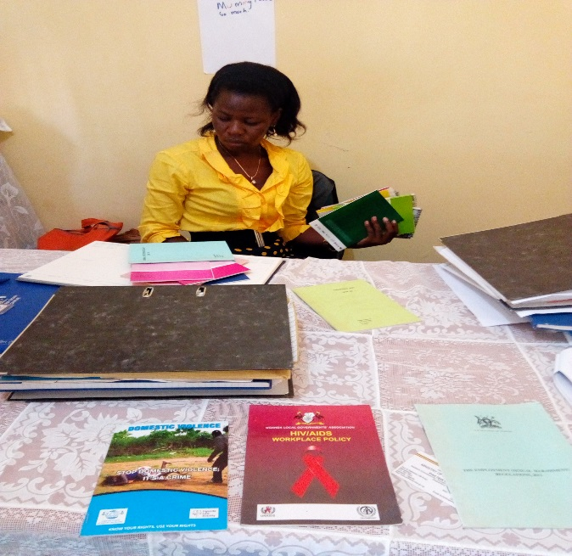

JOINT GOVERNMENT INSPECTION REPORT
(FIRST QUARTER 2018/2019)
AUGUST, 2018
Table of Contents
Executive Summary v
1.0 Introduction 1
1.1 Objectives of The Joint Inspection 1
1.2 Rationale for Joint Inspections 2
1.3 Methodology for the Inspection 3
2.0. Field Findings 4
2.1. Gulu District Local Government 4
2.1.1 District local government compliance with service delivery standards. 4
2.1.2 Availability of technical officers to implement government programs. 5
2.1.3 Development and Empowerment Programs in the District local government 5
2.1.4 General Challenges faced by the Department. 7
2.1.5 Methods of Improving Service Delivery 7
2.2 Gulu Municipal Council 8
2.2.1 Gulu Municipal compliance with service delivery standards. 8
2.2.2 Presence of Technical officers to implement government programs in the Municipal Council. 9
2.2.3 Availability of development and empowerment programs in the Municipal Council 9
2.2.4 Challenges facing the Community Development Department. 10
2.2.5 Measures to improve Service delivery 10
2.3 PAKWACH DISTRICT LOCAL GOVERNMENT 11
2.3.1 Pakwach District Local Government compliance to service delivery standards 11
2.3.2 Availability of Technical officers to implement government programs. 11
2.3.3 Community Development and empowerment programs in the Districts. 11
2.3.4 Ways of improving Service Delivery the Department 12
2.4 PAKWACH TOWN COUNCIL 12
2.4.1 Compliance with service delivery standards 12
2.4.2 Availability of technical officers to implement government programs. 13
Availability of Development and empowerment programs in the districts. 13
2.4.3 Challenges facing the Town Council 14
2.4.4 How the problem of Increased GBV cases are handled. 14
2.5 Serere District Local Government 14
2.5.1 Serere District Local Government compliance with service delivery standards 14
2.5.2 Availability of technical officers to implement government programs. 15
2.5.3 Development and empowerment programs in the district. 15
2.5.4 Challenges facing the Community Development Department 20
2.5.5 Recommendations to improve service delivery of the Community Development Department 21
2.6 Katakwi District Local Government. 21
2.6.1 Compliance of Katakwi District Local Government to service delivery standards 21
2.6.2 Availability of Technical officers to implement government programs. 21
2.6.3 Development and empowerment programs in the District. 22
2.6.4 Challenges faced by the department of community development. 26
2.6.5 Actionable recommendations to improve service delivery at the District 27
2.7 Ngora District Local Government 27
2.7.1 Ngora District compliance with service delivery standards 27
2.7.2 Availability of technical officers to implement government programs. 27
2.7.3 Available development and empowerment programs in the districts. 28
2.7.4 Challenges facing Community Development Department. 31
2.7.5 Recommendations to improve service delivery. 31
3.0 Summary of key challenges facing the YLP Program 32
4.0 Summary of Key challenges facing the UWEP program 33
5.0 Conclusion 34

List of Acronyms
MoFPED Ministry of Finance, Planning and Economic Development
MDs Ministries and Departments
LGs Local Governments
MDAs Ministries, Departments and Agencies
CDO Community Development Officer
DCDO District Community Development Officer
PWDs People with Disability
NGOs Non-Government Organization
AVSI Association of Volunteers in International Service
LC 1 Local Council 1
SAGE Social Assistant Grant for the Elderly
UWEP Uganda Women Entrepreneurship Program
YLP Youth Livelihood Project
GBV Gender Based Violence
UNFP United Nations Population Funds
VSO Voluntary Service Overseas
AGM Annual General Meeting
NUSAF Northern Uganda Social Action Fund
TASO The Aids Support Organization
MGLSD Ministry of Gender Labor and Social Development
HIV Human Immune Virus
AIDs Acquired Immune Deficiency Syndrome
GBS Gender Based Services
TERELEPAR Teso-Religious Leaders’ Efforts for peace and Reconciliation
OVC Orphanage and Vulnerable Children
ACDO Assistant Community Development Officer
BRAC Building Resources across Communities
IDI Infectious Disease Institute

Executive Summary
The Public Service must be accountable for its performance and the services it provides, in order to facilitate the attainment of the national vision and objectives. In that regard, a number of reforms aimed at enhancing the performance and accountability of public service organizations have been initiated and implemented.
One of the key strategies for this is strengthening a joint approach to inspections and performance measurement. Government Institutions have to be inspected regularly and their performance has to be rated periodically in order to identify and implement strategies for continuous improvement in the quality of public services. This requires institutionalizing a mechanism for rewarding Institutions that deliver excellent services and putting in place measures for improvement in those institutions that underperform. The rating of performance is also expected to promote healthy competition and innovation among Institutions in delivering quality and timely services to the citizens. To that effect, a Performance Measurement Tool for Ministries, Departments, Agencies (MDAs) and Local Governments (LGs) known as the Performance Scorecard, has been developed as an Inspection Tool to drive continuous improvements in the quality of services delivered to the citizens.

This Quarter, (First Quarter, 2018/2019), a Joint Inspection was carried out by the Ministry of Public Service, Office of the President, Ministry of Finance, Planning and Economic Development, Ministry of Health, Ministry of Education and Office of the Prime Minister. It was conducted in Six Districts. That is; Three in the Eastern Region (Serere, Ngora and Soroti) and Three Districts in the Northern Region (Gulu, Pakwach and Nebbi).

The key areas Inspected included; Gender, Community and social development, Human resource, Registry/ Records, Health and Education. At the end of the exercise, a debrief was held and Performance Score cards were administered to assess the performance of Districts and marks were awarded accordingly.

The Office of the President focused on Issues of Gender, Community and social development. The Programs under this unit were; NUSAF 3, YLP, UWEP, PWDs, and SAGE. It was noted that the best performing program in all the Districts visited was UWEP as this program met all its intended objectives in all the Districts visited.

It was also noted that SAGE was a very good Program and highly appreciated by the people however, it had its challenges such as difficulty to replace a deceased member, difficulty to pay deceased people as well as difficulty in deleting their names from the system. It was also noted that there was inequality in the distribution pattern of the beneficiaries as some areas have fewer elderly persons than others.

It was noted that in all the Districts visited, the YLP Program was still struggling due to the fact that most of the beneficiaries especially the First lot are not willing to pay back the funds received as they attach the Program to politics and therefore take it to be free money.

All in all, this approach of Joint Inspection to improve Performance of the Different Local Government is very fruitful as it encourages a sense of cooperation and positive competition among the Different Local Governments.

Likewise, Local Governments with challenges that are likely to affect service delivery are identified and given Technical support.

CHAPTER ONE

1.0 Introduction
According to the Uganda public service inspection manual, Government Institutions have to be inspected regularly and their performance has to be rated periodically in order to identify and implement strategies for continuous improvement in the quality of public services. One of the strategies for carrying out this is through the Joint Inspections. Joint inspection is an exercise carried out with different ministries covering different departments at local governments, municipalities and urban councils
During the inspection, the district local governments, municipalities and town councils are to be inspected and rated using the public service performance score card in order to identify and implement strategies for continuous improvement in the quality of public services. This requires institutionalizing a mechanism for rewarding Institutions that deliver excellent services and putting in place measures for improvement in those institutions that underperform.
The participants were to include all Government Ministries and Department, but only six confirmed participations in the exercise during the pre-field meeting. These included; Ministry of Public Service, Office of the President, Ministry of Finance Planning and Economic Development (MoFPED), Ministry of Health, Office of the Prime Minister, and Ministry of Education.
This inspection exercise covered Districts of Serere, Katakwi and Ngora in the eastern region and Gulu and Pakwach in the Northern region. The sectors to be covered included; Health, Gender, Labor and Social Development Sector, Production, Registry and Human resource.

1.1 Objectives of The Joint Inspection
- To find out if the district local governments are aware about existing policy guidelines.
- To find out if the district local governments have Technical officers to implement government programs.
- To capture information on the available empowerment and development programs in the districts.
- To identify challenges and propose actionable recommendations to improve service delivery.

1.2 Rationale for Joint Inspections
A joined approach to inspection of MDs, LGs and service delivery facilities is being promoted in order to:
- Institutionalize performance assessment against service delivery standards using the performance scorecard.
- Provide for a coordinated approach to planning and execution of inspection.
- Standardize and professionalize the inspection practice and process.
- Increase coverage of facilities, local governments and issues that are inspected.
- Increase efficiency gains in terms of cost, human resources and time for both the inspectors and those inspected.
- Improve the focus of inspection on issues that directly affect performance and service delivery.
- Collectively identity and address performance and service delivery gaps.
- Strengthen the incentive and sanction framework for compliance to performance and service delivery standards.

1.3 Methodology for the Inspection
The team held entry meetings with the respective Chief Administrative Officers (CAOs) of the different Districts visited and explained their intentions. The CAOs were then taken through the balanced score cards and requested to administer them to their subordinates. The CAOs then introduced the inspection team to the Local Government staffs for further interaction and assessment after which an exit meeting was held and the performance scorecards administered as a method of assessment of performance of the key inspection areas.
Figure 1; The Joint inspection team having a debrief meeting to fill in the Performance Scorecard with the officials from Katakwi District

2.0. Field Findings

2.1. Gulu District Local Government

2.1.1 District local government compliance with service delivery standards.

Availability of Policy Documents
The Department was well equipped with policy documents that guided the day today activities of the Department. Among the policy documents available were District Action Plan to address Gender Based Violence, Uganda National Culture policy, National Integrated Early Childhood Development Policy 2016. To mention but a few. These documents always provide references in handling cases or in carrying out activities.
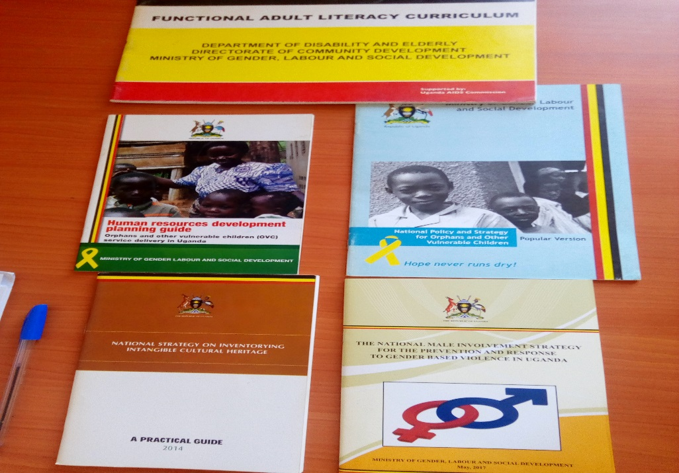
Figure 2: Available policy documents in Gulu District

Cross cutting issue of Gender
When the different Departments are budgeting, the aspect of Gender has to be reflected in their Budget.

Department Funding
The department is given Thirty-Six million shillings (UGX 36,000,000) for the entire Financial Year (2018/2019). This money is supposed to cater for all the activities of the different units under the department. The units include; Community development, Remand Home, Gender mainstreaming, to mention but a few henceforth the need to enhance the department budget.

Availability of Special Grant
The special grant for PWDs is Twelve million Uganda Shillings per Financial Year. It is regularly monitored by the Councilors.

Donor Funding
Donor funding is phasing out. Most of the Non-Governmental Organizations (NGOs) that were operating in Gulu have moved out since peace returned to Northern Uganda after the Lord Resistance Army (LRA) insurgencies. However, there are some NGOs such as Association of Volunteers in International Service (AVSI), Action Aid that are still working together with the District in matters concerning Gender and Social Development such as; Equal Opportunities Commission came with a team from Gender in 2017.

2.1.2 Availability of technical officers to implement government programs.
The structure of the Department is appropriate, however there are some gaps in the staffing as two positions are still vacant and yet critical for better performance of the Department. One of this vacant position is the senior CDO in charge of PWDs. We learnt that the person who had occupied this position had moved to Omoro District, a new District that was created in 2017.

2.1.3 Development and Empowerment Programs in the District local government

Community Mobilization
Community mobilization is done depending on the need and necessity and it is done through LC1 for awareness creation, community dialogue and dissemination of reports and through door to door sensitization although it is done rarely.

Programs for Community mobilization and empowerment
The District has Programs such as Women Entrepreneurship Program (WEP), Youth Livelihood Program (YLP), Social Assistance Grant (SAGE) for empowerment.
For the WEP Program, women entrepreneurs are given funds to venture into different business Enterprises. This Program has a restriction of women of ages between Eighteen to Sixty years of age. As of now, the Program supports few groups of women due to limited funds. Likewise, many of the women often don’t come forward to join these groups because of House Hold Limitations.
They also have the NUSAF Program where by different peasant farmers are given seedlings and other farming materials. Farmers are organized into groups and 50% of the combination in the group have to be women.
OWC is also another program run by the Local Government. Through this program, farmers are trained and given seedlings as well as other farm equipment.
SAGE is also another Program run by the District Local Government. This Program is Spear headed by Ministry of Labor, Gender and Social Development(MGLSD) who have recently opened up a regional SAGE office in Gulu. Although the Program is highly appreciated and welcomed by the people, not all the elderly persons are catered for in the program.

Challenges facing the SAGE Program
Some of the challenges facing this Program include; delay in payments to the Old Persons, the composition of persons under the SAGE Program is unfair as every sub-county has to place One Hundred (100) people on SAGE however some of the Sub counties have a higher proportion of the elderly persons than others.

Functionality of Adult Literacy
Functional Adult Literacy (FAL) is allocated Eight million Uganda Shillings (UGX 8,000,000) for the current Financial Year (2018/2019). There is also a conoraria that is Fifteen thousand shillings (15000 UGX) per Quarter that translates to Five thousand shillings per month (5000 UGX) given to FAL facilitators. Following the complaints raised by the facilitators that the facilitation given is too little, the District came up with a solution to this problem by withdrawing FAL programs from sub-Counties being facilitated by NGOs to create funds used to step up the fee to 15000 per month.
Generally, women respond very fast to adult literacy programs although most of them pull out of the program due to pressure from their homes.

Occurrence of Gender Based Violence(GBV)
Cases of Gender Based Violence (GBV) is very rampant. Most of the young people go into relationships when they are not yet ready for marriage or even to relate. Issues of poverty often takes a toll of them as the main cause of Gender Based Violence. According to the Senior Community Development Officer, almost 75% of the adults are cohabiting and therefore more prone to Gender Based Violence.

Programs to combart GBV
The District has come up with programs in response to the act of Gender Based Violence among which include;
- The GBV Shelter supported by Action Aid although the funding has reduced overtime.
- There are also other GBV actors that have come out to fight GBV as well.
- UNFP together with Ministry of Gender have 16 days of Actionism against GBV.

2.1.4 General Challenges faced by the Department.
The key issues affecting the Department include;
- Limited Funding of the Department (Thirty-six Million Uganda shillings for the Financial Year 2018/2019) which makes it close to impossible to run all the activities in the department.
- There is also a staffing gap in the department. The team was reliably informed that two key positions in the Department was not filled for example, the position of Senior CDO and yet this is key to ensure performance of the different Government programs.

2.1.5 Methods of Improving Service Delivery
In terms of Service delivery, the District has devised means of improving service delivery to the people, among which include; creating groups for people who would like to receive services that require one to be in a group, extending support to people who are already in groups, ensuring that the position of the Community Development Officer (CDO) is filled, ensuring that the sub-county Chiefs and area councilors are aware of the different Empowerment Programs so that they are able to monitor the programs, holding radio talk shows to create awareness to the people. Likewise, holding executive committee meetings.

2.2 Gulu Municipal Council.

2.2.1 Gulu Municipal compliance with service delivery standards.
Availability of Policy Documents.
It was evident that the Municipal Council had policy documents although some of them were out dated. For instance, the Gender policy needs to be reviewed. Among the policy documents found at the Municipal Council were; Child Policy
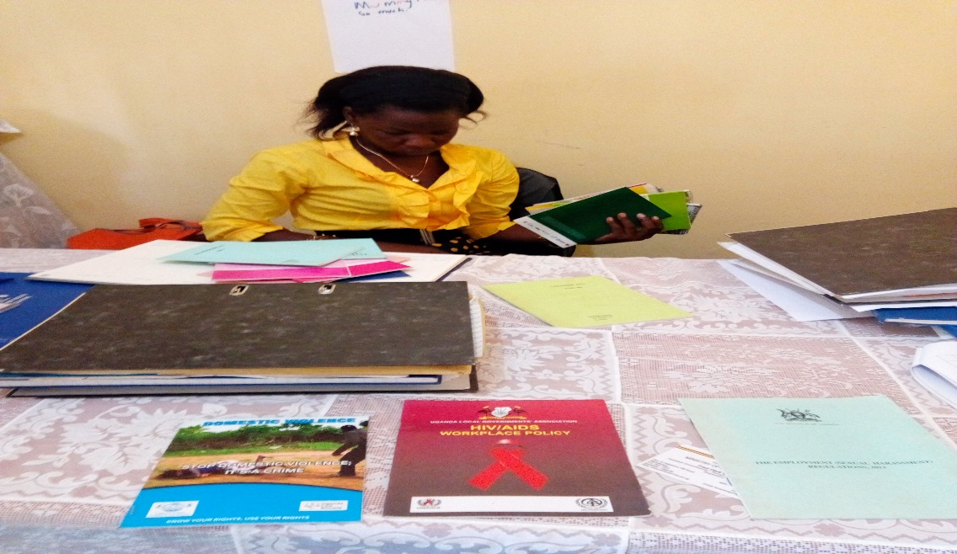
Figure 3: The Community Development Officer(CDO) of Gulu Municipal Council displaying some of the policy documents in her department

Departmental Budgeting
The Community Development Officer (CDO) informed the team that the budget is not sufficient and so most of the activities depend on conditional grants.

Availability of Special Grant
Special Grants is available and monitored annually by the CDO although the area Councilors monitor it quite often. The amount allocated as Special Grant is One Million, Five Hundred Thousand Shillings (1,500,000 shillings.)

Availability of Donor Funding
In regards to donor funding, the team was informed that most of the Donors do not work with the Municipal and rather work directly work with the District Local Government although, it is the Municipals that work directly with the people targeted by the Donors.

NGOs working with the Municipal Council
In regards to NGO funding, they informed that the Municipal Council is working with Voluntary Services Oversee (VSO) that mainly looks at teenage mothers.

2.2.2 Presence of Technical officers to implement government programs in the Municipal Council.
The Community Development Officer (CDO) informed the inspection team that there was no Senior CDO in the rank as far as the Structure is concerned. She stressed that if one was to become a Senior CDO, he/she had to cross over to the Divisions.
The Staffing position is at 90% with only the position of Probation officer not filled.
2.2.3 Availability of development and empowerment programs in the Municipal Council.
Community mobilization.
The Elder Persons Council was formed to handle issues of the Elder Persons although they have no funding

Programs for Community mobilization and empowerment
They informed that they had some Programs geared towards empowerment of the people in the community. These Programs were; YLP, WEP (women between 16 to 60 years) FAL, SAGE and Special Grant for the PWDs
The team was informed that WEP was so far the most successful Program they were running as the repayment rate is quite high. Forinstance in the Last Financial Year they were able to recover Forty-two Million Shillings (42,000,000 UGX). YLP was not performing as the Youths misuse the money given to them and also the fact that the group is too big, there is need to limit the number to at least five persons per group. The CDO informed that YLP was under review.

Presence of Child Related Programs
The Municipal does not have any Programs for the Children. Children who have been abandoned by their parents are referred to orphanages and Watoto Childcare centers. For the cases of Defilement and Child negligence, they refer these children to the police.
Likewise, there are no Programs for Orphans and Vulnerable children.

Availability of a GBV Center
They also informed that they did not have a GBV Centre.

GBV cases in the Municipal
In regards to Gender Based Violence, it was reported that these cases are still very high. These issues are always forwarded to the Gender Officer who sits at the District Headquaters since that position is not provided for by the structure at the Municipal Council although considering that this is an urban setting, it would be ideal to have this position in the current structure.

2.2.4 Challenges facing the Community Development Department.
Key Issues affecting the Department include;
Inadequate funding of the Department and the Municipal Council at large. The team learnt that the Bus Park was one of the key sources of revenue for the Municipal Council, however there was a presidential directive that the Bus Park only pays Eighty thousand shillings (80,000 UGX) per month opposed to the Eighty thousand shillings per day that they were paying previously. This has greatly impacted on the revenue of the Municipal Council.
Most of the NGOs work with the Districts and leave out the Municipal yet it is the Municipal Council that deals directly with the Youth.

2.2.5 Measures to improve Service delivery
Measures put forward to increase service delivery include; involving politicians once in a while in their planning as well as monitoring some programs, participating in radio talk shows, holding the Municipal Development Forum, calling for Annual General Meeting (AGM) whereby representatives from all members, academia, women, Youth and others are invited to attend.

2.3 PAKWACH DISTRICT LOCAL GOVERNMENT

2.3.1 Pakwach District Local Government compliance to service delivery standards

Availability of Policy Document
Pakwach District had a number of policy documents in place. They use these documents to guide them on different programs in the District

Department Budget
The budget for the Department is relatively low and hence there is limited outreach due to budget constraints.

Availability of Special Grant
The special grant is available and regularly monitored by the area councilors as well as the CDO. Although the CDO moves to monitor it on very rare occasions since the money is relatively so little and also lack means of transport to move around to monitor this fund.

NGOs that work with the Department
The District works hand in hand with Infectious Disease Institute (IDI) that supports health related issues. The District also works with MEMPRO, an NGO that is interested in working with Young mothers. Mothers.

Mainstreaming Gender at the Department
They mainstream Gender at work through holding meetings in which issues concerning Gender are raised and discussed. They also reflect on Gender through their budget.

2.3.2 Availability of Technical officers to implement government programs.

Staffing of the Department
The staffing is so poor with only two people in the entire department. Given the fact that there are quite a number of Programs under this department, there is need to improve on the staffing so as to be able to handle the workload.

2.3.3 Community Development and empowerment programs in the Districts.

Community Empowerment Programs
There were a number of community empowerment programs among which include; WEP, YLP, Special Grant for PWDs, SAGE
The SAGE program has a challenge of paying beneficiaries who have died. This is so because when someone dies, money which is already in the system delays to be paid. Likewise, there is a delay in the enrolment of alternative or replacements of the deceased.

Availability of Child-related Programs
There are also some programs for children who are either orphaned or Neglected. The District has a probation officer who is always available to handle these cases.

Responses to GBV Cases by the District
The CDO informed that they respond to GBV cases through counselling, prioritizing certain aspects of a famility such as roles and responsibilities of a mother and father.

Availability of FAL at the District
They have a Focal Point Person for FAL at the District who is concerned with the issues of Adult Literacy.

2.3.4 Ways of improving Service Delivery the Department
The CDO informed that Service Delivery is improved through; Calling and informing the public about the available programs in the District, conducting field monitoring, handling of Probation cases at the level of sub-county as well as training of new teams.

2.4 PAKWACH TOWN COUNCIL

2.4.1 Compliance with service delivery standards

Presence of Policy Document
It was evident that Pakwach Town Council Gender and Community Development department had no Policy documents to guide their actions with the Community.

Department Budget
In regards to the budgeting, it is done basing on different revenue sources. The budget for the department is Sixty Million Uganda Shillings (60,000,000 UGX) and the local Revenue is Seven Million Uganda Shillings (7,000,000 UGX). Ministry of Tourism contributes One Hundred Three million Uganda Shillings (103,000,000 UGX) for the department. This is because they have a game park that has elephants which loiter around and destroy peoples crops from the garden therefore the money MoT gives is mainly for compensation.

Availability of a Special Grant for PWDs
A special grant is given to cater for the PWDs however this grant is relatively small. (Six million for the Financial Year.)

NGOs working with the Town Council
The NGOs that work with the Council include; CSO Jonam Youth Development initiative that supports the Town Council with issues of sexual reproductive Health.

Mainstreaming Gender at the Town Council
Gender Mainstreaming is reflected in their budget as well as their training schedules.

2.4.2 Availability of technical officers to implement government programs.

Staffing of the Department
The department structure was designed to have three staff; that is Senior Assistant Legal, Senior CDO and Assistant CDO however, since formation, (3 years) the Town Council has been running with only one staff (Senior CDO).

Availability of Development and empowerment programs in the districts.

Community Development Programs
The Town Council has a number of programs for social development among which include;
WEP who’s funding comes direct to the District Local Government. The major work of the Department at the Town Council is to prepare the women groups. Fund are submitted to the District. This program is doing so well with a very high repayment rate.
NUSAF 3, although it has no operational fund. The design of this program was intended for lower level governments although work is still with the District.
According to the senior CDO, YLP has totally failed as most of the Youth are not willing to repay back the money. It is important for government to use micro finances to give out these YLP money so as to eliminate the perception of free money.

Availability of Child Programs at the Town Council
There are no special Child Programs in the Town Council.
There is a probation Officer in-charge of Child programs. There is a Child Development Centre that deals with Children. These issues that affect children include; Child negligent, domestic violence. According to the senior CDO, cases of child neglect is always due to the fact that boda boda men impregnate girls and abandon them

Functionality of FAL
Adult Literacy was not functional for the last three years however it is already starting although it is not yet operational however Alwee Sub-county does not want to get involved in the FAL program.
The Council was given three motorcycles in 2012 for monitoring the different programs at the Municipal however they are currently all broken down and so this makes it complicated to monitor the programs.

2.4.3 Challenges facing the Town Council

GBV cases in the Town Council
It was also reported that cases of Gender Based Violence are on the rise, although the cause is yet to be established.

2.4.4 How the problem of Increased GBV cases are handled.
The CDO always moves to Sub-counties to educate the community about matters of Gender Based Violence and other issues affecting the community.
Communities are have also become more willing to report cases of rape and violence.
Para social workers have been formed and this has helped reduce the GBV cases as people now report to the police.

2.5 Serere District Local Government

2.5.1 Serere District Local Government compliance with service delivery standards

Availability of policy documents.
The District had a number of policy documents that were used as point of reference for different programs. Among the policy Documents included; The AIDs policy, Youth policy and the Child policy.
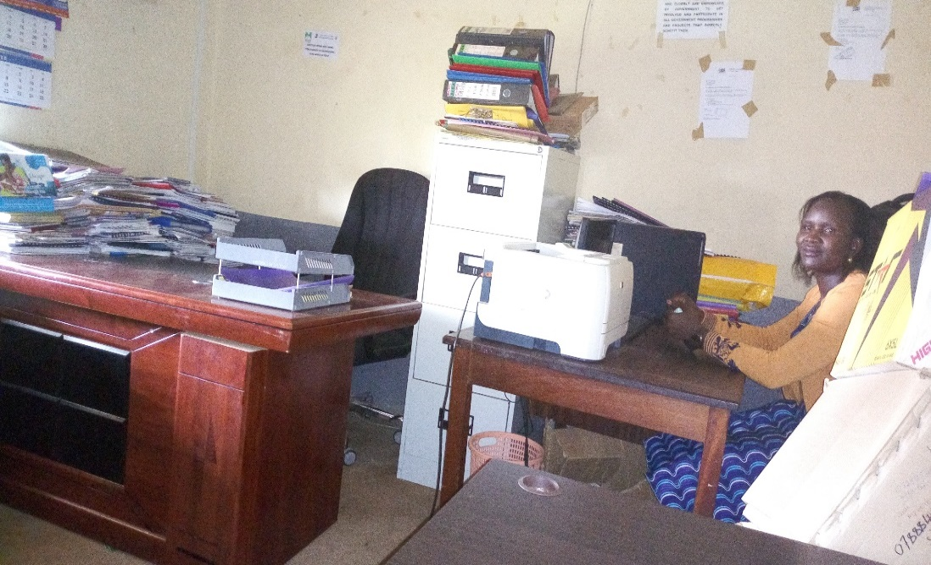
Figure 4; The CDO of Serere District Local Government interacting with the officer from Presidents Office.

NGOs working with the District Local Government to improve service delivery

The team was informed that the NGOs focusing on culture and family included; TASO, Hope after Rape, Village to Village, How –Uganda while NGOs with activities targeting gender and women affairs. Included; Safe-Teso, Teso Religious Leaders Effort for Peace and Reconciliation (TERELEPAR).

2.5.2 Availability of technical officers to implement government programs.
The technical positions were 90% filled with only the position of Labor officer being vacant

2.5.3 Development and empowerment programs in the district.

Programs in place for Community development and empowerment
Programs for Community Based Services at the District Local Government included; UWEP, YLP, OVC, Special grant for PWDs and FAL.
While the Town Council had the following programs for Community Based Service
- Buying sanitary pads for school going adolescent girls
- Buying question paper for Primary School candidates in government schools.

Community Development and Literacy Programs
At the time of the inspection, the district had the following (four) 4 programs for community mobilization and empowerment UWEP, YLP, NUSAF and Restocking Program at the Town Council.

UWEP Program
The UWEP program at the time of the visit was in place and operational. The program started in the financial year 2016/17. It received Sixty million, five hundred eighty-three thousand Uganda shillings (UGX 60,583,000). Although the total beneficiary groups approved at the time of inspection were 37, only 12 had received the money. 14 groups were expected to receive the funds in the coming week while the remaining 11 groups are to receive later when more funding is advanced to the district. At the time of inspection, Eight million, nine hundred thousand Uganda shillings (UGX 8,900,000) had been recovered from the first 12 groups.

Achievement of UWEP program
The achievements of the WEP program include;
- Flourishing projects as The received funds were well invested in profitable business ventures by the group beneficiaries
- Improved livelihood of the group beneficiaries as they have been able to realize increased income from their group business ventures.

Challenges faced by UWEP program
- Overwhelming number of applications visa vie limited funds for the Program. It was evident that the District received so many number of applicants for the Program for instance, in the last Financial year (2017/2018), over 300 groups applied for the funds which made it very difficult for the district to select the final beneficiaries of the Program as it had to approve only thirty (37) groups.
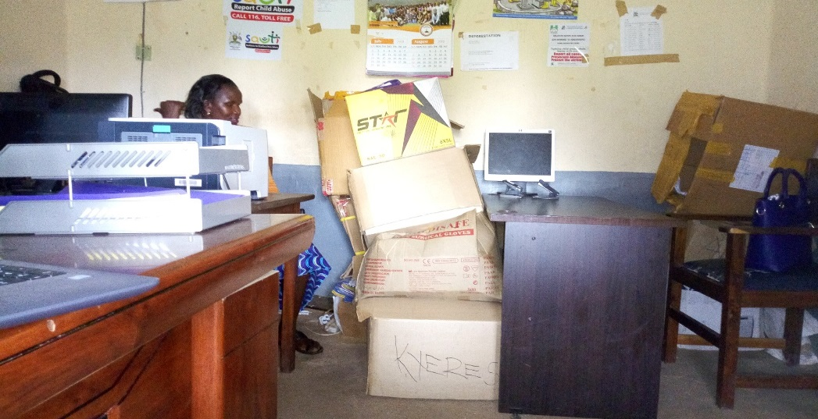 Figure 5 : The focal person of Serere District showing boxes containing application documents for UWEP funds.
- Delayed release of both operational and program funds. This makes it very difficult for the groups to plan their activities accordingly. At the time of the visit, the inspection team found out that fourteen (14) groups had not yet received the WEP funds for the last financial year (2017/2018).
- Insufficient funds for both operational and program funds. Out of the Thirty-seven (37) approved groups, twelve (12) groups were not able to receive the funds until more funds are advanced to the district.
- Budget cuts. Out of the Eighteen million Uganda shillings (UGX 18,000,000) planned for the financial year 2017/18, only Eleven million Uganda shillings (UGX 11,000,000) operational fund was received indicating a deficit of Seven million shillings (UGX 7,000,000).

Measures in place to recover UWEP funds.
The District has put in place several measures to recover the WEP funds. These include the following.
- Members are always encouraged to pay back within the agreed period.
- Joint monitoring by both the district local government and MGLSD.
- Arresting of the non-compliant group members. The members are well informed that in case they fail to fulfil their obligations, arrest as the last resort will be effected.

Recommendations to improve UWEP program
- There is need to increase both operational and program funds.
- Timely release of both operational and program funds so as to enable the Program achieve its planned targets.

Programs for the prevention, response and/or elimination of Gender-Based Violence (GBV)
- Community mobilization & sensitization
- Stakeholders meetings with police, LC1, District Local Government, opinion leaders, councilors
- Counselling of the victims for GBV

Program for Mainstreaming Gender and Rights
Trainings in lower local governments, town councils and district local government officials on matters concerning Gender mainstreaming during orientation of new staff are conducted.

Disability and Elderly

Special grant for PWDs
At the time of the visit the district had a special grant for PWDs. The grant was equivalent to an average of UGX 1,500,000 which varies from one quarter to another thus affecting proper planning for the fund. The fund is used to facilitate planning meetings, supporting PWDs groups and DOVC. The fund is not sufficient to meet all the above mentioned activities.

Monitoring PWDs grant.
Due to little funds available which is not even reliable, the fund is monitored quarterly.

Non-formal adult literacy services.
The district had FAL program in place

Facilitation for adult literacy instructors
Due to late quarterly release of funds, adult literacy instructors are facilitated quarterly.

Social Assistance Grant for Empowerment (SAGE)
At the time of the visit, the district did not have SAGE program.

Youth and Children Affairs

Programs for the Promotion of Children and Youth
YLP and Orphanage and Vulnerable Children

Programs are in place for Orphans and other Vulnerable Children
Under OVC, TASO supports orphans and vulnerable children by providing medical care, school fees.

Youth Livelihood Program (YLP)
The YLP at the time of the visit was in place and operational. The program started in the financial year 2014/15. The program received One billion, thirty-six million, six hundred forty-four thousand and sixty-four Uganda shillings (UGX 1,036,644,064) which had so far helped 150 beneficiary groups but at the time of inspection, only One hundred sixty-four million two hundred seventy eight thousand two hundred shillings (UGX 164,278,200) had been recovered indicating 16% recovery rate.

Achievements of YLP
- Improved livelihood. Okulonyo produce buying & selling Group dealing in buying produce when monitored, they had a full store of produce which they want to sell & clear all the balance.
- Kamod Central B Produce Buying & Selling, bought rice milling machine which is helping them to mill & sell rice.

Challenges facing YLP
- Youth not willing to pay back especially the pioneer groups. This is because the program was implemented at the time of elections which the youth still believe the program fund is an appreciation from the president for winning the election.
- Insufficient operation fund. For example, two hundred thousand Uganda shillings (UGX 200,000) facilitation given to ACDOs per quota which is in most cases inconsistence makes it difficult for ACDOs to do regular monitoring.
- Most youth have left the district without trace.
- Group disintegration.
- Transport problem. No vehicle at the district and no motorcycles at town council and sub counties for field activities. The team discovered that ACDO at Serere town council hires “a bodaboda” to do community outreach activities.
- Poor business management practices like poor record keeping.
- Political interference.
- Some group refused to attend trainings (Aboche youth events management)

Strategies for recovery
- Monitoring
- Persuading the group members to payback.
- Arrest of non-compliant group members as last resort.

Recommendations to improve the program
- Reduce the group members to 5 instead of the current 15 which is a big number for the youth to come together.
- Timely release of operation funds.

Social services extended to vulnerable persons
- Psychosocial support/counselling
- Community mobilization & sensitization
- Skills enhancement training on income generating activities

Measures taken by the District to improve service delivery
These measures include;
- Community mobilization and sensitization about ownership of the programs
- Lobbying for more funds from government and NGOs such as The AIDS Support Organization (TASO), Hope after Rape, Village to Village and How –Uganda.

2.5.4 Challenges facing the Community Development Department
- No photocopy, they have only one file cabinet and no book shelf
- Inadequate funding for the department.
- No vehicle for community based department which makes monitoring of projects and programs very difficult.
- No office tea and drinking water
- Congested office space with no sufficient sitting place for staff and clients.
- Vacant post for labor officer.

2.5.5 Recommendations to improve service delivery of the Community Development Department
- Procurement of file cabinets and bookshelves.
- Budget enhancement for office operation funds
- Recruitment of labor officer

2.6 Katakwi District Local Government.

2.6.1 Compliance of Katakwi District Local Government to service delivery standards

Availability of policy documents
The Department of Community Development had the required policy documents in place. These policy documents help them in handling different programs and projects in the district. Some of the policy documents included; The National OVC policy(2010), The Youth policy, the AIDs policy, and others.

Special grant for PWDs.
At the time of the visit, the team found out that the district has Elderly and disability Grant for PWDs

NGOs working with the Local Government.
The NGOs in place include; Action Aid and BRAC, Orphanage and Vulnerable Children (OVC), The AIDS Support Organization (TASO), Action Aid, BRAC, Child Fund, Partners for Children Worldwide, UNFPA, Katakwi Children’s Voice(KCV), War on Want (WOW), Teso Diocese Development Foundation(TEDDO), Soroti Catholic Diocese Integrated Development Organization (SOCADIDO), Teso Initiative for Peace(TIP), Straight Talk Foundation, UNICEF, Magon FALISO, Teso Women Peace Activists(TWPA).

2.6.2 Availability of Technical officers to implement government programs.
The team found that the staffing level of the Department of Community Development was at 90% with only the position of Labor Officer not yet occupied. There is also room for career growth. At the time of the visit, the team found out that 08 Assistant District Community Development Officers (ADCDO) have been promoted to DCDO.

2.6.3 Development and empowerment programs in the District.
The district has the following programs for Community mobilization and empowerment;
- Youth Livelihood Program (YLP)
- Social Assistant Grant for the Elderly(SAGE)
- Uganda Women Entrepreneurship Program (UWEP)

Gender and Women Affairs
The district had UWEP program for Strengthening of Women Entrepreneurship. The program started on 20th July, 2017. The program has so far enrolled 54 groups with 639 members. The program has received UGX 234,154,200= but at the time of the visit, it was not possible to identify how much so far had been recovered because the program focal was not well versed with that information which could only be got from regional offices. However, the DCDO claimed that recovery for this program was much better than YLP.

Achievements of UWEP
- Katakwi district was able to generate the only kills development project under Epikosi Ikiliok metal Fabrication and Welding group located in Mangoro sub country in the whole country. This project had attracted visitors not only from MGLSD but also surrounding districts for benchmarking.
- Integration of men into women groups
- Improved income and livelihood of women group members.

Challenges facing UWEP.
- Prolonged drought for last two years.
- Delayed disbursements of both the operation and program funds.
- Budget cuts affecting smooth running of the program.
- Distant bank.
- Poor monitoring of groups due to insufficient operation funds.
- The program fund is not sufficient to benefit overwhelming number of applicants.

Strategies in place to recover UWEP funds
- The bank had appointed agents within the villages for easy accessibility and recovery of the program funds.
- The beneficiary groups were tasked to sign financing agreements and loan repayment schedules.

Recommendations
- Government should increase the program fund to enable the district handle overwhelming number of applicants.
- Provide motorcycles to Community Development Officers for easy mobilization, sensitization, monitoring and follow up.
- The district should engage women councils in the program.

Programs for the prevention, response and/or elimination of Gender-Based Violence (GBV).
The district holds quarterly district coordination meetings supported by NGOs.
Program for Mainstreaming Gender and Rights.
- Integration of gender concerns into planning and Implementation through District Technical Persons Committee (DTPC).
- Capacity building of staff.
- Monitoring at sub county by Community Development Officers (CDOs), parish chiefs and local councils.
- Monthly monitoring by district as need arises..

How PWDs grant is monitored
The inspection team was informed that PWDs grant is monitored quarterly due to insufficient operation funds.

Non-formal adult literacy services.
The district had only FAL program for non- formal adult literacy in place.

Facilitation of Adult literacy instructors.
Although the adult literacy instructors are supposed to be facilitated monthly, the district facilitates them quarterly.

Social Assistance Grant for Empowerment (SAGE) program.
The district has SAGE program which started on 13th March, 2014. Katakwi being an old and pilot district local government, there was mass enrollment of the beneficiaries including migrants who had stayed in the place for more than six months. A verification exercise was carried out to confirm the eligibility of the beneficiaries. During this exercise, ghost names and those below targeted age barrack were removed. The district had only one focal person for the program who coordinates SAGE activities in collaboration with the regional team.

Achievements registered by SAGE program.
- Improved hygiene of the elderly.
- Treatment cost for the elderly has been reduced
- Some beneficiaries who bought hens had multiplied to cows leading to economic empowerment.
- The elderly with orphans are able to pay their school fees.
- Improved livelihood.
- Reduced death occurrences.
- The elderly persons feel proud to be recognized by the government.
- The elderly persons are now able to join savings group.

Challenges facing SAGE program
- Payment using MTN mobile money was characterized by theft. At times beneficiaries were paid less money than disbursed. Many beneficiaries lost money which had not yet been traced.
- Delayed payment of the deceased to the designated persons.
- Irregular payment of beneficiaries by post bank which makes following the arrears very difficult if not impossible.
- Payment delays for both staff and beneficiaries thus affecting smooth running of the program.
- Many people will be left out in the incoming enrollment to be done by electoral commission since most of the elderly are not registered by the electoral commission and others were registered with errors.

Recommendations to improve the SAGE program
- With death proof from LC chairperson, hard cash should be paid to the deceased beneficiaries to enable them meet burial expenses.
- Operational fund should be increased and released on time.
- Timely monthly payment to all the beneficiaries.
- A technical staff should be appointed to implement the program at the district.

Youth and Children Affairs
Programs in place for the Promotion of Children and Youth include; YLP, Youth Councils and OVC.

Programs for Orphans and other Vulnerable Children.
OVC program had entrepreneurship training, startup capital and equipment, Education sponsorship, giving seedlings to parents of the beneficiaries, house hold assessment done by CDOs, School feeding done by some NGOs like Juvenile justice and OVCMIS data capture.

Operation for Youth Livelihood Program (YLP).
At the time of the visit the district had YLP program in place that started on 22nd September, 2016. The program enrolled 97 groups and had so far received Seven hundred thirty-seven million Uganda Shillings (UGX 737,000,000) The groups had paid back One hundred six million Uganda shillings (UGX 106,000,000) Taking recovery as the percentage of the disbursed funds, recovery rate stands at 21%.

Achievements of the YLP
- Animals kept by some Groups engaged in animal husbandry multiplied making it possible for groups to split up and do individual activities.
- Reduced idleness among the youth who used to be involved in gambling.
- The program has given the youth golden opportunity to be involved in business activities hence increasing their incomes and standard of living.

Challenges faced by YLP
- Poor recovery due to prolonged drought for the last 2 years affecting all agricultural projects.
- Most of the youth are not business oriented due to low levels of education and lack of skills for best business practices like proper record keeping.
- Diversion of funds to address basic needs than the planned activities due to high levels of poverty.
- Conflict of interest affecting cooperation leading to group disintegration.

Strategies to improve YLP program
- Frequent dialogue with the youth to make them obliged to pay back for sustainability of the program.
- Constant visiting and monitoring the youth groups and advising them on the best practices e.g. groups rearing animals had concentrated on multiplying animals but when visited they were advised to sell some of the animals and payback.
- Arresting non-compliant group members as the last resort. Some group members from Mangoro and Ongongoja when arrested, were forced to sign commitment letters before release. This example prompted other group members that had defaulted to start paying back.

Recommendations to the challenges faced in YLP
- Project redesign. Given that most of the youths are illiterate, more training is required for them to get the required skills to run the business and make their projects very successful.
- The district should help the youth to identify viable projects that will enable them to accumulate wealth and payback for other youth to benefit from the program.
- Operation fund for the program should be increased and be released on time to facilitate smooth running of the program.

Equity and Right
The team found programs in place program for Probation Services within the district. OVC handling case management of family issues concerning child neglect/abuse, placement of Youth in institutions for skills training and Youth councils.
programs in place for Community Based Services.
At the time of the visit, the team found the following programs for the community based services; UWEP, Women Councils, FAL, SAGE, Micro Projects e.g. (Disability Grant), OVC, Data Capture and Youth Councils.

Social services extended to Vulnerable persons
Social service to the vulnerable persons are targeted with ongoing government programs in the district e.g. SAGE for the elderly, UWEP for women, YLP for youth, Micro Projects for disabled persons and OVC for orphans and vulnerable children.

2.6.4 Challenges faced by the department of community development.
- The post for labor officer at the district is vacant. Due to the sensitivity and relevancy of labor issues, this post should be filled.
- The operational fund that handle issues like fuel, tyres and facilitation of CDO insufficient.
- Delays in payment of operational fund affects smooth running and follow up of the programs.

Measures in place to improve service delivery including coordination; monitoring and evaluation.
- Recruitment of staff. At the time of the visit, the team found out that 01 staff District Community Development Officer (DCDO) had been recruited two months ago.
- Promotions. The team found out that 08 Assistant District Community Development Officers (ADCDO) have been promoted to DCDO.
- Lobbying for more funds from government, NGOs for example The AIDS Support Organization (TASO), Welt Hunger, RHITES

2.6.5 Actionable recommendations to improve service delivery at the District
- Recruitment of labor officer.
- Enhancement of operational fund.
- Timely payment of releases.

2.7 Ngora District Local Government

2.7.1 Ngora District compliance with service delivery standards

Availability of policy guide lines.
The team found several policy documents at the District. Among these policy documents was the Child policy, The AIDs policy, the National OVC policy (2010).

NGOs working with the District Local Government.
The NGOs working with the District are; HEIFER International and Ngora youth network an association in charge of youth advocacy, Grace for Rural Orphans and Widows. Edith Home, New Hope Uganda, Ngora Child Development Centre, MORU KAKISE Integrated Development Association, Vision TERUDO, Build Africa Uganda (BAU)

2.7.2 Availability of technical officers to implement government programs.
The team was informed that the posts for labor officer, senior community development officers and CDOs for the 2 town councils and sub counties are vacant which affects community based services.

2.7.3 Available development and empowerment programs in the districts.
The Programs for community development and empowerment include; YLP, UWEP

Programs for Strengthening of Women Entrepreneurship.
At the time of the visit, the district had UWEP program for strengthening women entrepreneurship which started 2016/17 financial year. The program had enrolled 18 groups but at the time of the visit, the team found out that 13 groups had received funds in June 2018 and had not been able to pay back any funds. Out of One hundred twenty three million Uganda shillings (UGX 123,000,000) received, only One million nine hundred thousand Uganda shillings (UGX 1,900,000) had been recovered from the first 5 pioneer groups.

Achievement of UWEP program.
- Improved livelihood for the beneficiary group members.
- Increased income.

Challenges facing UWEP program.
- Conflict and division leading to disintegration of some groups.
- Overwhelming number of applicants.
- Release of operational funds.
- Insufficient funds. The district received Eight million, one hundred thousand Uganda shillings (UGX 8,100,000) out of Eleven million (UGX 11,000,000) financial year entitlement which was shared among the district local government, 04 sub counties, 01 town council and women council leaders.
- Theft of group funds for example the chairperson and secretary for Opot United Women Group stole Five million Uganda shillings (UGX 5,000,000) which prompted other group members to report the matter to police leading to their arrest.

Strategies to recover the funds.
Involvement of all the stakeholders RDC, DISO, community members, sub counties and women councils.

Recommendations to improve UWEP program.
- Operational and program funds should be increased and released quarterly for proper planning.
- Regular monitoring and sensitization of group beneficiaries.

Programs for the prevention, response and/or elimination of Gender-Based Violence (GBV).
In regard to GBV, the district receives support from Vision TERUDO and TASO for capacity building, meetings and handling reported cases of GBV.

Program for Mainstreaming Gender and Rights at the workplace.
Mainstreaming Gender and Rights normally handled during DTPC meetings, training the stakeholders, at departmental level, e.g. in health HIV, works and transport, orientation of new staff has a component of public service gender issues.

Disability and Elderly

special grant for PWDs
The team found out that the district had a special grant for PWDs.

Monitoring of PWDs grant.
The monitoring of the PWDs grant is done on quarterly basis by the executive members of the district disability council and district special grant committee guided by the CDOs.

Non-formal adult literacy services.
The team found FAL program in place at the district.

Social Assistance Grant for Empowerment (SAGE) program.
At the time of the visit, the district had not yet benefited from SAGE program.

Youth Livelihood Program (YLP)
At the time of the visit, the district had YLP in place which started 2014/15 financial year. The program has so far enrolled 109 beneficiary groups. Out of Eight hundred sixty one million Uganda shillings (UGX 861,000,000) so far received by the program, only Ninety four million, seven hundred fifty six million Uganda shillings (UGX 94,756,000) had been recovered at the time of the visit.

Measures in place to recover the funds
- Writing letters to the sub counties clearly indicating strategies and reminding them to recover the funds from beneficiaries.
- Holding regular meeting with stake holders and sub counties to formulate new strategies to recover the funds.
- As a last resort after all the above measures have failed, with engagement of police and RDC, group beneficiaries are arrested. Examples of arrested youth group members include; Ngora Complex youth Turkey Rearing, Gawa Youth Turkey rearing, and Agolitom Youth Turkey Rearing.

Achievements of YLP.
- Improved livelihood. Koloin Youth and Extraction group received UGX 7,400,000 and bought 14 bulls which are used for ploughing. The group has so far paid back UGX 6,000,000 without selling any of the bulls which has helped the group to reduce hiring animal labor hence increasing their incomes.
- The youth fund is easily accessible when compared to loans from other financial institution
Challenges facing the YLP.
- Political interference which has greatly affected recovery of the funds
- Group disintegration
- Division of the funds to other activities than the planned activities
- Bad example from the youth leaders

Recommendations to the identified challenges facing the YLP
- The guidelines of the program should be amended and the youth leaders should not be allowed to access the fund.
- Signatories to the youth accounts should be the youth themselves to reduce on theft of the fund. The chairperson of Kapiri Integrated Youth Farmers, Patrick Oding disappeared with Four million Uganda shillings (UGX 4,000,000) for the group.
- The current required number of the group members (minimum 10 and maximum 15) should be reduced to minimum 3 and maximum 5 for easy management.
- The fund should target youth who are already involved in some business activities to help them expand the business.
- The youth should be given adequate training. The current 2-3 days training is not sufficient to impart the required skills to the youth majority of whom are illiterate.
- Enhance operation fund to improve on sensitization, inspection and monitoring.
- Timely release of both the program and operation funds.

Programs in place for Community Based Services.
The team found out that the district receives community workers grant given to CDOs at sub county for community based activities.

Strength of community development department
- The staff are provided with office tea.
- The department has 2 computers for YLP and UWEP programs and 1 printer for YLP
- The office has 1 old cabinet and 1 book shelf.
- The office has 2 motorcycles for YLP and UWEP programs for community based services.

2.7.4 Challenges facing Community Development Department.
- The office does not have a photocopy. The clients photocopy for themselves.
- The office does not have intercoms yet the secretary seats 1 km away from office. This makes communication very difficult.
- The posts for labor officer, senior community development officers and CDOs for the 2 town councils and sub counties are vacant affecting community based services.

2.7.5 Recommendations to improve service delivery.
- Provide staff with drinking water.
- Recruitment of staff to fill the vacant posts for labor officer, senior community development officer and CDOs should be filled to improve on service delivery
- Provision of transport for CDOs for easy community mobilization, sensitization and monitoring.
- Enhance community mobilization grant. The existing fund (UGX 1,200,000 per quarter) is too little to facilitate 2 ACDOs and 2 CDOs.

Measures are in place to improve service delivery.
- Community mobilization and sensitization about ownership of the programs
- OPM & RDC organize meetings where community development officers account to the public about the programs in place and their performance.
- Partnering with development partners e.g. Heifer International that give soft loans to the youth age bracket from 15 to 24 years, Build Africa supporting education, TASO supporting health, orphans and vulnerable children

3.0 Summary of key challenges facing the YLP Program
There were key challenges raised that were limiting the performance of the YLP Program. The table below shows the key issues raised in all the Districts visited concerning the YLP Program
S/N | Issue | Actionable Recommendation
1 | The YLP program design does not meet the complexity of dealing with Youths | There is need to review the YLP Design so as to be able to come up with a Best-fit for the Youth.
2 | Most of the Youths have no attachment for the groups in which they have been placed. | There is need to give money to Youths groups which have long been in existence as these groups tend to have firm foundations and henceforth more organized.
3 | Lack of transport for the CDOs to monitor the progress of the program. | There is need to provide motorcycles to CDOs so as to enable them coordinate and monitor the program
4 | Considering the fact that one of the requirements to access the YLP fund is for the group to be composed of 10-1 members, this makes the Group quite big and therefore limits accountability from the members. | There is need to limit the number of people in each group to Five members maximum. This makes it easy to
5 | Lack of ownership of the Program by the Youth as they consider the YLP Government money and hence free money. They therefore lack interest in paying back these funds given to them | There is need to consider the option of using Micro-Finances to disburse these funds to the Youth as micro-finances are well versed with issues of loan recovery.
6 | There is no policy backing to allow punishment of the Youth who have either failed or refused to refund the YLP money they accessed | There is need to formulate policies that provide a legal backing to enable Responsible officers punish the YLP loan defaulters.

4.0 Summary of Key challenges facing the UWEP program
Below is a summary of challenges facing the UWEP Program and the Actionable recommendations to the identified challenges in all the Districts visited.

S/N | ISSUES | ACTINABLE RECOMMENDATIONS | RESPONSIBLE MDA
1 | Delayed disbursements of both the operation and program funds. | There is need to release both operational and program funds on time. | MoFPED
2 | Budget cuts affecting smooth running of the Program for example in Serere district, out of UGX 18,000,000= planned for the financial year 2017/18, only UGX 11,000,000= operational fund was received indicating a deficit of UGX 7,000,000= million. | There is need to provide all the funds that have been planned for the UWEP activities. | MoFPED
3 | Poor monitoring of groups due to insufficient operation funds and lack of transport for CDOs. | There is need to provide motorcycles to Community Development Officers for easy mobilization, sensitization, monitoring and follow up. | MGLSD
4 | Overwhelming number of applicants. The program fund is not sufficient to benefit all the qualified applicants as the budget is often cut. | Government needs to increase the program fund to enable the district handle the overwhelming number of applicants. | MGLSD  MoFPED
5 | Prolonged drought for the last two years thus affecting agriculture projects. | There is need to Sensitize the group members about water harvesting and irrigation | CDOs
6 | Conflict and division leading to disintegration of some groups for example in Ngora district, the chairperson and secretary for Opot United Women Group stole UGX 5,000,000 which prompted other group members to report the matter to police leading to their arrest and disintegration of the group. | Involvement of all the stakeholders RDC, DISO, community members, sub counties and women councils to oversee the operations of the Women groups | District Local Governments

5.0 Conclusion
Using the Score Card method, the performances of the Districts were assessed and results obtained. In the Eastern Uganda, Serere District was the best performer with 67% of the three Districts visited. Ngora District came second with 66% and their performance was ranked as good. Katakwi District came third with 59.5% and its performance was ranked as fair.
In Northern Uganda, Pakwach was ranked as the best performer of the two Districts visited with 69% followed by Gulu District with 60.5%.

Although the districts visited had programs in place to improve service delivery, some of the programs especially YLP were not doing well as they were not meeting their intended objectives. Likewise, the recovery rate of the YLP Program was relatively low as most of the Youth tag the YLP to politics and thus think it is free money. However, the WEP Program was generally doing very well in all the Districts visited although the funds are still limited to only a few groups of women.

During the debrief meeting, it was noted that Most of the challenges facing the districts are beyond their control. To address those challenges therefore the Districts need interventions and lobbying from both the Central Government Ministries especially MoFPED and MGLSD and NGOs.

