
OFFICE OF THE PRESIDENT
DIRECTORATE OF SOCIO-ECONOMIC MONITORING AND RESEARCH (DSEMR)
A REPORT ON THE PROCEEDINGS OF THE INDUSTRIAL POLICY REVIEW DIALOGUE MEETING
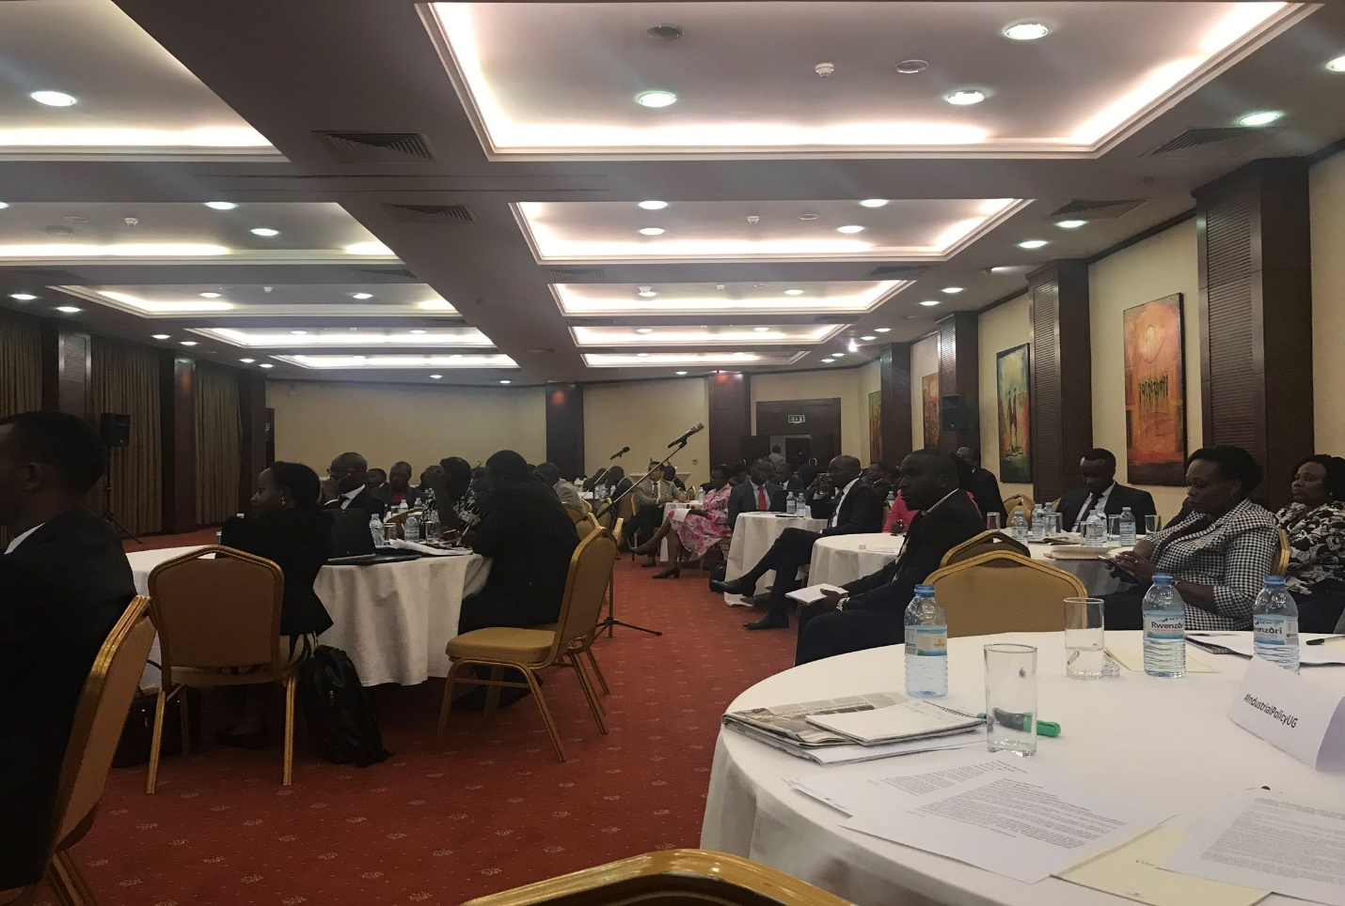
THEME:
An Inclusive Industrial Policy Review Dialogue
“To Inform Policy Development”
Tuesday, 20th November 2018

Executive Summary
Industrial development is one of the priorities of the Government of Uganda (GoU). Both the Uganda vision 2040 and the second National Development Plan 2015/16-2019/20(NDPII) target industrialization as one of the means of the transforming Uganda’s economy into a middle-income country.
In line with the above, a high level meeting with the theme “Triggering Economic Transformation in Uganda: Industrial policy re-visited?”; was held on 30th May 2018 between Office of the President, Cabinet secretariat, State House, Office of the Prime Minster, National Planning Authority(NPA) and Friedrich-Ebert-Stiftung (FES). An issues paper was developed highlighting the key emerging issues, action points and recommendations to inform the transformative industrialization and manufacturing activities that will propel Uganda towards the achievement of vision 2040.
Among the key issues identified were; the industrial policy framework remains generic without proper coordination and linkages among Ministries, Departments and Agencies (MDAs),there is a growing trade deficit for Uganda from US$ 210 million in 1987 to US$3.7 million in 2017(IMF,2018), the first National Development Policy (NIDP) focused on agro-processing and mineral beneficiation but didn’t prioritize manufacturing, Uganda’s manufacturing industry is largely engaged in the production of low-value good, worryingly produced by mostly small and medium sized enterprises (SMEs), Uganda’s agro-industries depend on peasant suppliers without technological upgrading, the concept of the industrial parks is being haphazardly implemented without proper feasibility studies, the present national trade policy undermines industrialization as it favours importers over manufactures/exporters.

The recommendations included; ensuring capitalization of UDC by the state and giving full support to incubate industries to minimize “learning costs” for the private sector, harmonize the National Development Policy (NIDP) with other policies and strengthen the monitoring frame work, revising the key national policies, re-orient the macro-economic framework towards supporting the country’s industrialization agenda, focus the NIDP and the IMP to specific and realistic products, focus the NIDP and the IMP on long-term development of the sector and its contribution to the wider economy, undertake feasibility studies of the planned industrial parks, develop guidelines for accessing industrial development incentives such as tax exemption, provide viable long term and affordable development finance to manufactures, legislate and enforce competition and Anti-Trust Laws
Following the outcomes of the above meeting, the Office of the President found it appropriate to organize another meeting which would be more inclusive by bringing on Board all key stakeholders of the Industrial policy so as to discuss the above identified issues and come up with an agreed position that would be more representative so as to inform the industrial policy that is currently under review.
A meeting code named “An inclusive Industrial policy dialogue” was organized by Office of the President with support from Friedrich-Ebert-Stiftung. Academicians, representatives from Government Ministries, Departments and Agencies as well as the Civil society were invited for the dialogue.
The issues identified by the meeting participants included; Getting the State pro-actively Involved in Industrialization, harmonizing the National Industrial Development Policy with other related policies, ensuring the Macro-Economic Framework is conducive for the Industrialization Agenda, harmonization of the Industrialization Master plan and industrial Policy, weak collaboration between Academia and Practitioners, lack of effective policy co-ordination in government , weak leadership in Public Policy Management , Corruption and Poor policy implementation, Emphasis on Local Content and making provisions for the protection of Local investors in Uganda, Harmonization of Trade Policy Descent employment policy, skills development and the Industrial, Review of key National Policies that facilitate operationalization of Industrial policy, Legislate and enforce competition and anti-trust laws,
The key recommendations agreed on by the meeting included; Re-Capitalization of and Supporting Incubation of Industries, Decision Criterion for State Support to Industries, Ensure harmony with policies related to; Training, skills and technology development, Infrastructure Development, Agriculture and Environment, Financial Sector, Occupational safety Standards, Investment Land policy and Investment Code, Exchange Rate Stability, Study the two frameworks(Industrial master plan and industrial policy) and harmonize, Legislate and enforce competition and anti-trust laws for promotion and regulation of competition in the private sector, Development of a mechanism to link practitioners and academia for evidenced based decision making, Explore the possibility of policy protection provisions for local investors against low end investors, Studying areas of convergence and ensuring that the industrial policy provides for descent jobs and is consistence with the employment policy under review, Taking stock of key policies that need review, Analyze and assess the possibility of incorporation .
The Office of the President informed members that it would take leadership in policy making as mandated by the constitution of Uganda. It offered to work with Ministry of Trade, Industry and Cooperatives (MTIC), to ensure that all the actionable recommendations were taken up by MTIC and catered for in the revised Industrial Policy so as to ensure that it is representative and vibrant.

Contents
Executive Summary i
List of Acronyms iv
1.0 Introduction 1
1.1 Background 1
1.2 Objectives of the Breakfast Dialogue Meeting 1
1.2.1 Overall Objective 1
1.2.2 Specific Objectives 2
1.3 Methodology of the Breakfast Dialogue Meeting 2
1.4 The participants 2
2.0 Proceedings of the Breakfast Dialogue Meeting 2
2.1 Arrival and Registration of guests 2
2.2 Introduction, welcoming and opening Remarks 2
2.3 synopsis of the revised industrial policy 6
2.4 Presentation of the Issues Paper 7
2.4.1 Emerging issues 7
2.4.2 Recommendations 7
2.5 Panel discussions 8
2.6 Plenary discussion 10
2.6.1 Online plenary discussions retrived from FES Uganda twitter accounts 11
2.7 Closing remarks 36
3.0 Concluding remarks 38

List of Acronyms

GOU……………………………………. Government of Uganda
NDP II…………………………………. National Development Plan II
GDP……………………………………. Gross Domestic Product
OP………………………………………Office of the President
FES…………………………………… Friedrich-Ebert-Stiftung
MTIC……………………………………Ministry of Trade, Industry and Cooperation
NPA………………………………….... National Planning Authority
MDAS…………………………………. Ministries, Departments and Agencies
SEATINI Uganda………………………Southern and Eastern Africa Trade Information Uganda
SME……………………………………. Small and Medium Enterprise
MUBS…………………………………. Makerere University Business School
IMF…………………………………. International Monetary Fund
NIDP…………………………………. National Development Policy
UDC……………………………….......Uganda Development Cooperation
IMP……………………………………Industrial Master Plan

1.0 Introduction
Industrial development is one of the priorities of the Government of Uganda (GoU). Both the Uganda vision 2040 and the second National Development Plan 2015/16-2019/20(NDPII) target industrialization as one of the means of the transforming Uganda’s economy into a middle-income country. The aspiration is to increase industrial sector contribution to GDP to 31 percent, increase the share of the labor force in industry to 26 percent, and increase the manufactured exports as a percentage of total exports to 50 percent by 2040.The theme for national for 2017/18 and 2018/19 was “Industrialization for job creation and shared prosperity.”
This report seeks to document the proceedings of the dialogue meeting code name “Inclusive Policy Review Dialogue.” Which took place on the 20th November, 2018 at Serena Hotel. This meeting was organized by the Office of the President (O.P) in partnership with Friedrich-Ebert-Stiftung (FES) Uganda.

1.1 Background
A number of studies have been conducted to examine the main features of Uganda’s Industrial policy and its implementation challenges(FES,2017) to review and update the National Industrial Development Policy(MTIC,2018) and to develop Uganda’s first Industrialization Master Plan(NPA,2018). Other studies have also attempted to assess Uganda’s progress as far as her Industrialization agenda is concerned (Office of the President,2018: FES,2017; Obwona et al,2013)
In line with the above, a high level meeting with the theme “Triggering Economic Transformation in Uganda: Industrial policy re-visited?”; was held on 30th May 2018 between Office of the President, Cabinet secretariat, State House, Office of the Prime Minster, National Planning Authority(NPA) and Friedrich-Ebert-Stiftung (FES) and thus developed an issues paper highlighting the key emerging issues, action points and recommendations to inform the transformative industrialization and manufacturing activities that will propel Uganda towards the achievement of vision 2040.
Following the above high level meeting, the Office of the President proceeded to organize a multi-stakeholder dialogue to present the issue paper developed; and to discuss the implementation of the new Uganda Industrial policy under review by the Ministry of Trade, Industry and Cooperatives(MTIC) with the overall goal of having a vibrant industrial and manufacturing sector.

1.2 Objectives of the Breakfast Dialogue Meeting

1.2.1 Overall Objective
The overall Objective of the Breakfast Dialogue Meeting was to ensure an inclusive industrial policy review by all Ministries, Departments, Agencies, Academia, Civil Society Organizations and other stakeholders so as to inform policy development.

1.2.2 Specific Objectives
- To give a synopsis of the Revised Industrial Policy to all members.
- To present the developed issues paper to all members.
- To inclusively discuss the future of Uganda’s industrial and manufacturing sector.
- To collectively identify policy recommendations following the debate among members.

1.3 Methodology of the Breakfast Dialogue Meeting
The methodology involved presentation of the meeting agenda for the, “inclusive industrial policy review dialogue to inform policy development” by the moderator. A synopsis of the revised industrial policy was given by the assistant commissioner, Ministry of Trade, Industry and Cooperatives and the presentation of Issues paper done was by an Economist from Makerere University Business School. Thereafter, was a Q&A session followed by a panel discussion on their views about this topic, followed by a plenary discussion of the paper presented and later on, a summary of the debate and policy recommendations by the Director, Office of the President.

1.4 The participants
The meeting was attended by representatives from the following MDAs;
- Office of the President (O.P)
- Friedrich-Ebert-Stiftung (FES) Uganda
- Ministry of Trade, Industry and Cooperatives(MTIC)
- National Planning Authority (NPA)
- Ministry of Finance, Planning and Economic Development(MoFPED)
- Makerere University Business School (MUBs)
- Uganda Freezone Authority
- Makerere University
- Uganda Textile
- Workers’ Union
- SEATINI

2.0 Proceedings of the Breakfast Dialogue Meeting

2.1 Arrival and Registration of guests
The invited guests started arriving at 7:30am and by 9:00am all of the guests had arrived, registered and had their breakfast tea. By 9:15am, all the guests had settled down and were ready to begin the meeting.

2.2 Introduction, welcoming and opening Remarks
Mr. Vincent B Tumusiime, the Director Socio- Economic Monitoring and Research, Office of the President gave welcoming remarks and introduced the purpose of the dialogue to the participants. He stated that the industrial policy was introduced in 2008 and is currently under review. He further appreciated the efforts made by Ministry of Trade, Industry and Cooperatives which put the new draft policy in place.
He stated that in May 2017, the Office of the President (O.P) had a snapshot of the implementation of National Industry policy but felt it was not effectively implemented. It therefore partnered with FES to hold an inclusive industrial policy dialogue meeting to further discuss the issues identified from the earlier meeting. He noted that the revised industrial policy done by Ministry of Trade, Industry and Cooperatives (MTIC), had been pushed to the level of approval by Cabinet however, it was recalled because it had so many loopholes and policy gaps which needed to be collectively discussed/dialogued with other stakeholders to address those policy gaps. At the 30th May meeting, it was agreed that there was need to come up an issues paper capturing all issues raised by the stakeholders which would be captured by MTIC to have a more representative policy.
He further noted that coming up with a policy is one thing but implementing it is another and thus a policy framework needs to be inclusive and well stated.
The Resident Director Friedrich-Ebert-Stiftung (FES) Uganda, Ms. Mareike Le Pelley welcomed members to the dialogue. She stated that the chief role of the government is to develop socio-economic order to improve lives and ensure that people live in dignity. She further noted that, National Development Plan II (NDP II) objectives state that the role of the state is to prevent social and economic development in a free society. She also stressed that NDP II talks about the main goals as wealth creation, employment and inclusive growth. And that, Vision 2040 elaborates this in greater detail at social services, human development and many other areas
She noted that to achieve social justice and attain development, the importance of industrialization is increasingly being recognized as a source of employment creation.
She stated that we have to move from policy to action and implementation, and that day’s focus was on the important work done by stakeholders in coming up with the industrialization master plan. The meeting was to look at the industrial plan being developed by National Planning Authority (NPA), and pay attention to sectors that provide employment, labor and agro processing.
She thanked OP and resource experts such as director- DSMER, Mr.Ramathan Goobi and others for putting the paper together, and all other experts who attended because contributions of all stakeholders were important.
Mr. Willis Bashasha, Ag. Secretary- Office of the President thanked people for sparing time to attend. He stated that industries provide the environment for development; creating jobs creates inter sectoral links and this enables agriculture sectors to expand, can improve health, education system, alleviates poverty. He noted that industrial policy is an important sector for the government both in the NDP II and vision 2040, it contributes 31%of GB, 26% of labor, 50%total exports by 2040. Over the last 10 years the country had registered a number of approved policies such as; national standards policy, national leather policy 2014, national SME-2010, grain trade, package water policy 2015.
He said that the Industrial policy should aim at providing jobs for the young people joining the Labor market.
He noted that the Office of the President with support of FES Uganda held stakeholders meeting in May to improve the industrial policy under review. He concluded by thanking FES Uganda and other stake holders for working hard to enable the policy address. He then declared the meeting officially opened.
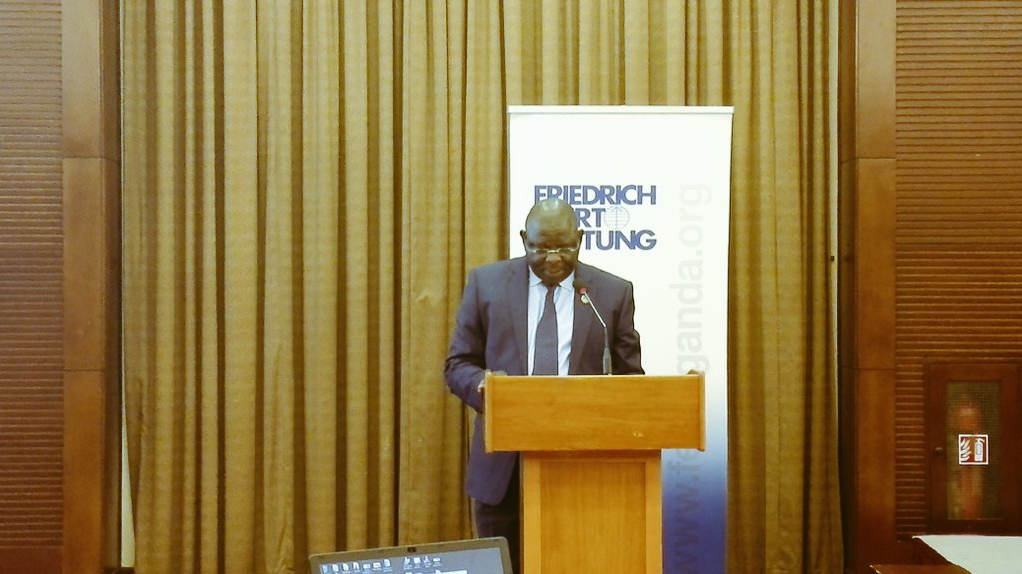
Figure 1 The Director, Directorate of Socio-Economic Monitoring and Research-Office of the President delivers his welcoming remarks
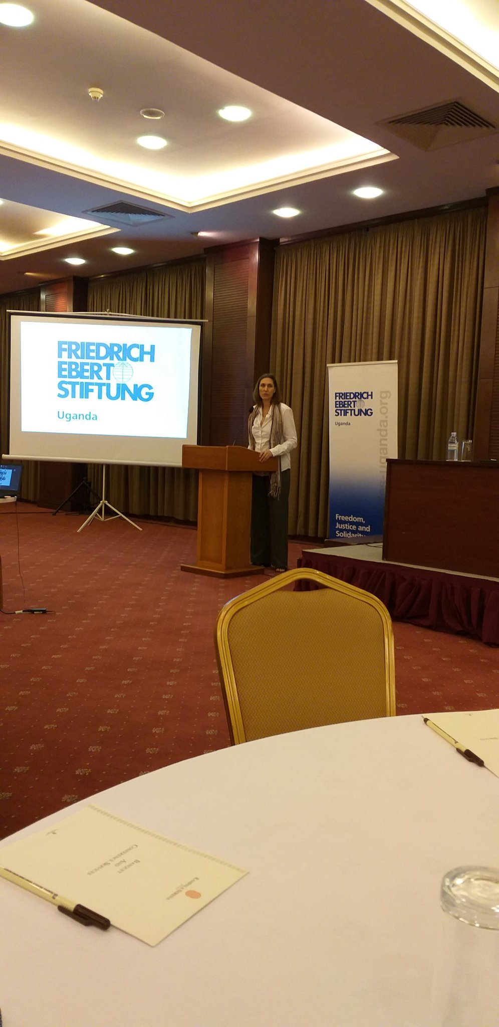
Figure 2 The Resident Director Friedrich-Ebert-Stiftung (FES) Uganda, Ms. Mareike Le Pelley giving her welcoming remarks.

2.3 synopsis of the revised industrial policy
The synopsis of the revised industrial policy was presented by the Assistant Commissioner, Ministry of Trade, Industry and Cooperatives who was the first presenter of the day as follows.
- The government plays a fundamental role in ensuring that financial markets work better; skilling Ugandans and promoting research to support industrial development.
- As result of Limited role of the State in implementation of the 2008 industrial policy; only 30% of the policy strategies were implemented. The role of the State has to be stepped up.
- Private sector led industrial policy is the primary driver in economic growth of the country.
- Policies need to help create the enabling environment for private sectors to operate efficiently and effectively.
- There is need to link the economy to global value chain so as to trigger efficiency and effectiveness.
- The revised industrial policy aims at;
- inclusive sustainable development
- Sustainable livelihood: skills development, middle income status
- Economic integration and production
- Descent jobs for people
- Expanding fiscal revenue to boost production for the mass

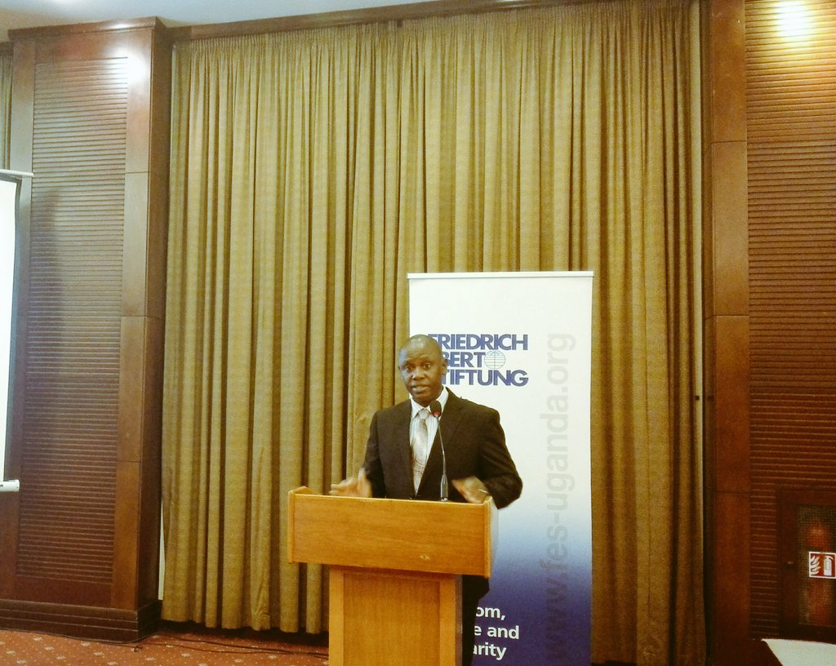
Figure 3 Assistant Commissioner, Ministry of Trade, Industry and Cooperatives giving a synopsis of the revised industrial policy

2.4 Presentation of the Issues Paper
The session was moderated by Mr. Maurice Mugisha who invited the second presenter of the day Mr.Ramathan Ggoobi an Economist from MUBS to make his presentation .The presentation highlighted the emerging issues, recommendations and key implementing agencies as summarized below;

2.4.1 Emerging issues
- The industrial policy framework remains generic without proper coordination and linkages among Ministries, Departments and Agencies (MDAs).
- There is a growing trade deficit for Uganda from US$ 210 million in 1987 to US$3.7 million in 2017(IMF,2018)
- The first National Development Policy (NIDP) focused on agro-processing and mineral beneficiation but didn’t prioritize manufacturing.
- Uganda’s manufacturing industry is largely engaged in the production of low-value good, worryingly produced by mostly small and medium sized enterprises (SMEs).
- Uganda’s agro-industries depend on peasant suppliers without technological upgrading.
- The concept of the industrial parks is being haphazardly implemented without proper feasibility studies.
- The present national trade policy undermines industrialization as it favours importers over manufactures/exporters.

2.4.2 Recommendations
- Ensuring capitalization of UDC by the state and giving full support to incubate industries to minimize “learning costs” for the private sector.
- Harmonize the National Development Policy (NIDP) with other policies and strengthen the monitoring frame work.
- Revise the key national policies.
- Re-orient the macro-economic framework towards supporting the country’s industrialization agenda.
- Focus the NIDP and the IMP to specific and realistic products.
- Focus the NIDP and the IMP on long-term development of the sector and its contribution to the wider economy.
- Undertake feasibility studies of the planned industrial parks.
- Develop guidelines for accessing industrial development incentives such as tax exemption
- Provide viable long term and affordable development finance to manufactures.
- Legislate and enforce competition and Anti-Trust Laws

He then concluded by saying that policy documents alone will not industrialize Uganda, Therefore GoU should lead this agenda by acting and learning from the mistakes and failures. He also noted that industrial development should become a political priority in action funding, not in talking and policy papers.
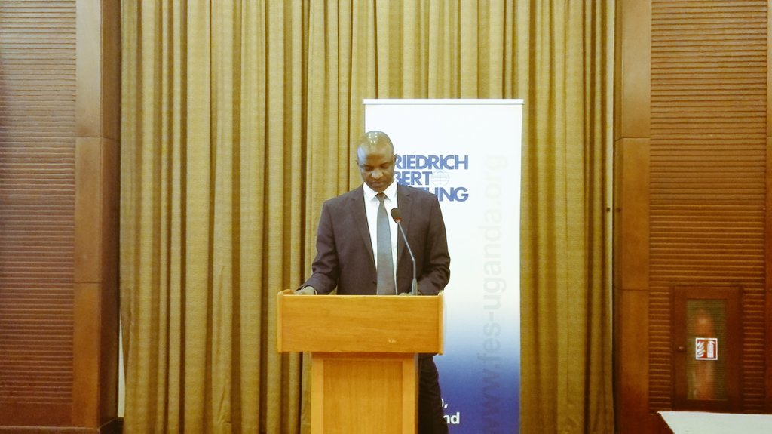
Figure 4 Mr.Ramathan Ggoobi, an Economist from Makerere University Bussiness School making a presentation on the Issues Paper that arose out of the 30th May, 2018 meeting organized by Office of the President.

2.5 Panel discussions
The first discussant was the Commissioner SMEs, Ministry of Trade, Industry and Cooperatives Dr. Joshua Mutambi, who started the discussion by appreciating the presenter for giving the discussion insights. He stated that the speed at which industrialization in Uganda is moving is slow compared globally but this has been due to different challenges like power, tariffs, lack of better industrial parks and many others. This indicated that the entire system needs to be checked. He gave an example of china where the available power and skilled human resource has propelled their industrial sector. He noted that if Uganda could do the same given the fact that it has infrastructure as well as the required labor. He concluded by saying that Uganda is moving in the right direction of industrialization through this industrialization policy since power generation has increased and the industrial sector still growing, infrastructural development is also prioritized and there is presence of abundant cheap labor.
The second panel Discussant was Eng. George Bwanga the Manager Infrastructure, Industry and physical planning at National Planning Authority. He said he was pleased with the fact that the same team using the same methodology was working on both the industrial policy and the industrial sector master plan. This, he said would result into documents that are well coordinated. He noted that the issue of implementation came out in previous presentations very strongly. However, the reasons that hinder implementation are what they are trying to address through coming up with an industrial master plan and policy. He added that there is need to develop a system where there will be linkages between various sectors of the economy, for instance agriculture, industry, energy, and others.
The third Discussant was Mr. Okot Kiwanuka (representing Mr. Kenneth Mugambe) from Ministry of Finance Planning and Economic Development who said that discipline can no longer rely on people’s benevolence therefore, Monitoring and Evaluation as a function of planning needed to be strengthened. There is need to design a framework to punish individuals in the value chain who do not essentially deliver their mandates.
The fourth discussant was Mr Ramathan Ggoobi an Economist at Makerere University Business School who thanked the Office of the President for pledging to resume its leadership role. He also thanked MoFPED for stating that the state is back in business. He added that for systems to work, there has to be one institution to stand out and lead. He said that Uganda’s liberalization as required by IMF and World Bank, was done excessively which was not so necessary. He said that there is need for policy to state the particular model and area that industrializing should follow
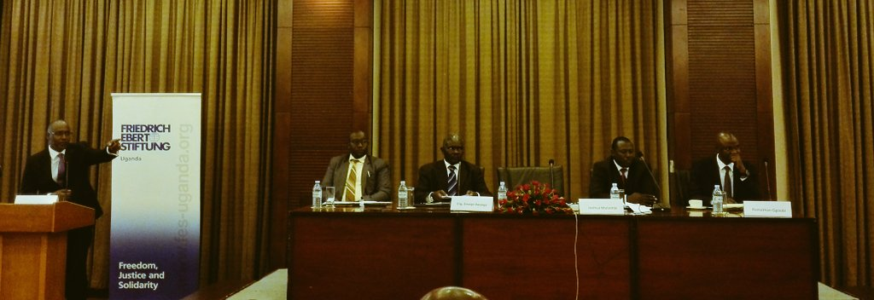
Figure 5 A panel of experts discussing the future of Uganda’s industrial and manufacturing sector.

2.6 Plenary discussion
A participant stated that first and foremost, there is no bad policy if it is correctly implemented. He categorically stated that in his view, with his age and experience, in Uganda we do not implement what we plan, we instead implement what we think. He added that planning is a strategic discipline which is not available in this country. He said that the implementation challenge noted by other participants was not the main problem, the problem goes beyond that, to luck of coordination in what is being planned and implemented. Mismanagement, corruption and selfishness is also another virus affecting this generation. He concluded by saying that taking individual decrees and words as policies is very wrong and should not be carried on.
A participant urged all spokespersons of government Ministries, Departments and Agencies to disseminate information to the public so that citizens can know what government is doing and what policies are being implemented. She also added that the relationship between local and foreign investors should be clearly spelled out. The investment areas should be clearly demarcated. She concluded that the issues of standard should be taken with keen interest in the policy.
A participant from the Directorate of Socio-Economic Monitoring and Research, Office of the President noted that according to previous submissions by other participants, there are mainly three problems, that is; implementation, coordination, lack of patriotism and ethical standards. He noted that these issues affect both the government and private sector. Therefore, respecting the policies and laws ought to be strengthened in the country.
A participant from Makerere University invited fellow participants to appreciate the fact that the issue of development and industrialization is a war, he therefore called for war generals and marshals to approach the issues raised by the meeting. He also added that Uganda must change development ideology from the private sector led development to state led development. The state needs to take back the driving seat in the economy. He concluded that Uganda needs to employ a defiant strategy, to defy skepticism, comparative advantage and negative hopes.
A representative from Uganda textile and workers’ union, said that to her disappointment, the Ministry concerned with labour in the country was not present in the meeting to ensure laborers are well catered for in the revised policy. She informed the members that the workers on the flow are not decently treated, they face unfair termination from work, and their rights are trampled on. The investors do not follow the labour laws, therefore there is need to include labour laws and rights in the industrial policy.
Another representative from free zone Uganda, suggested to the meeting that Uganda needs to shift from just ring fencing industrial parks as a way to boost industrialization and focus on creating free zones. There is need to create facilities ready for an industry to settle in and start producing.

2.6.1 Online plenary discussions retrived from FES Uganda twitter accounts
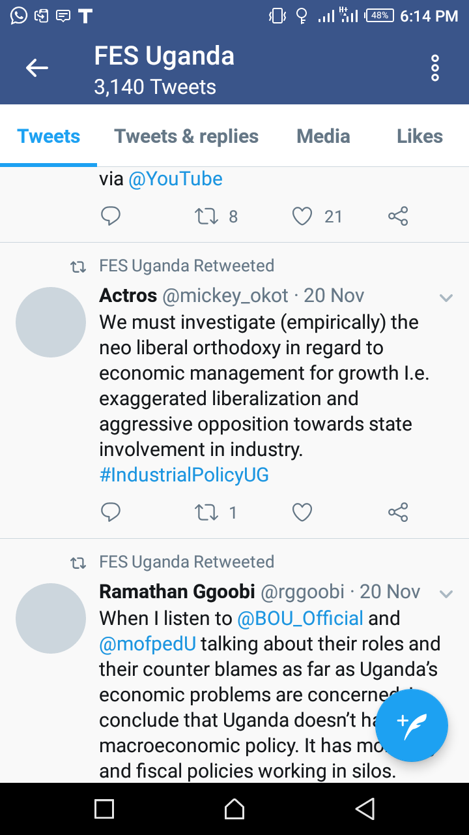
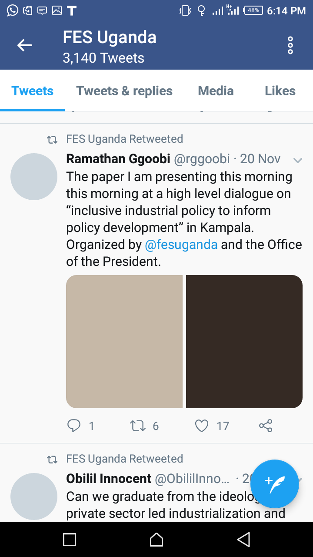
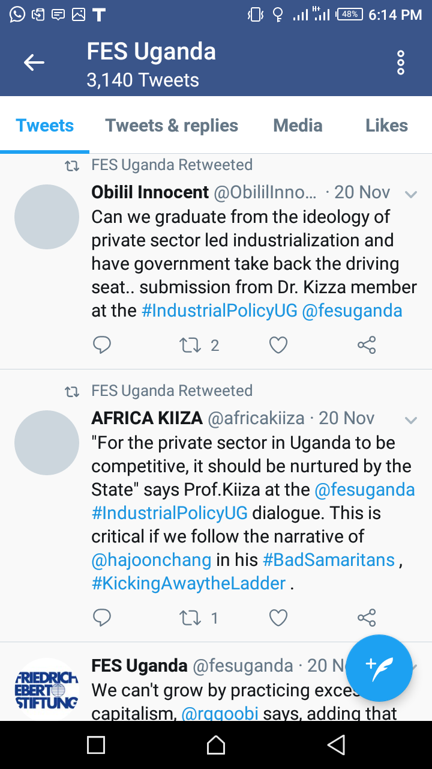
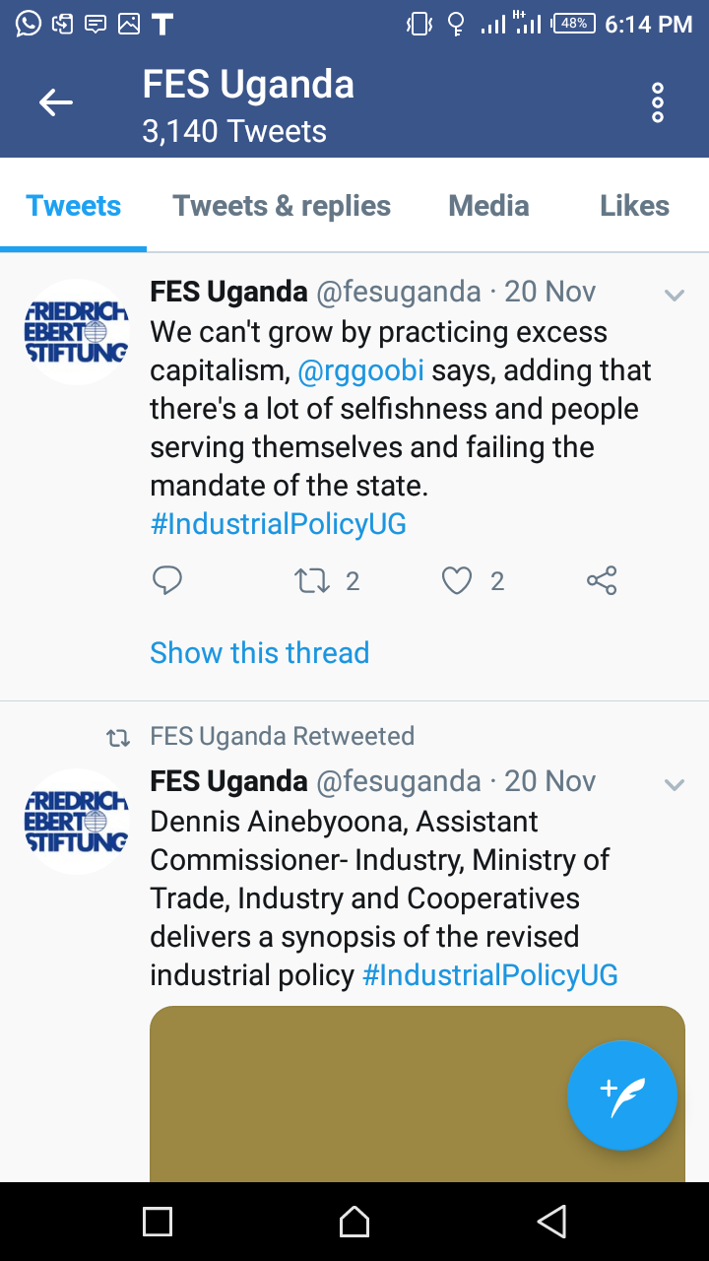
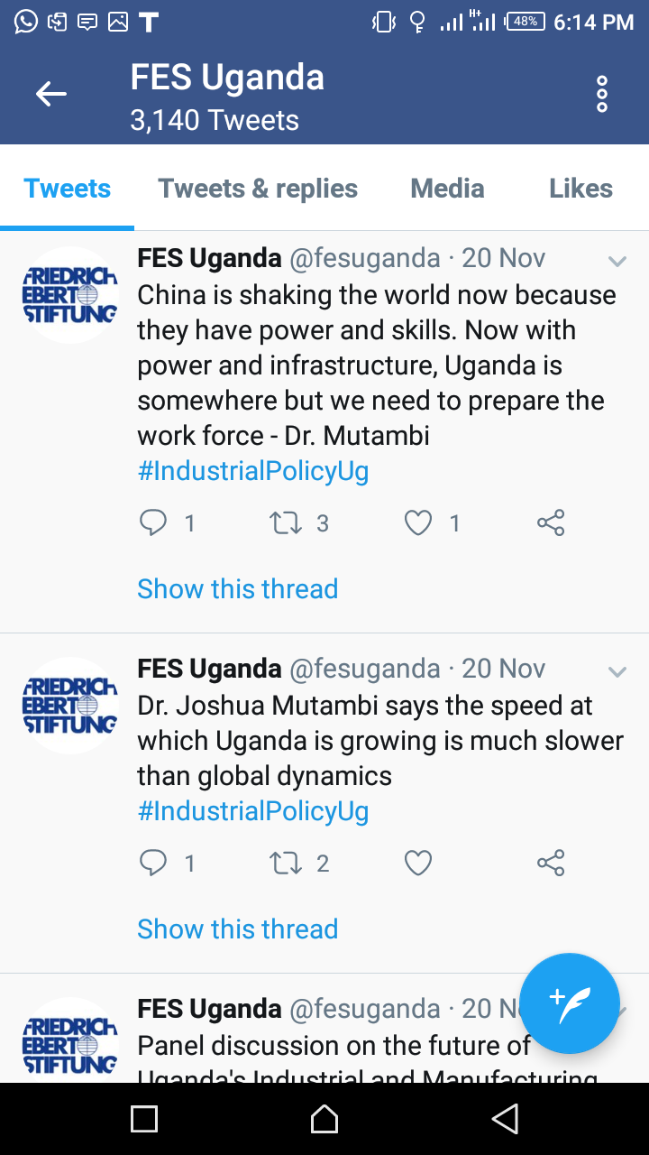

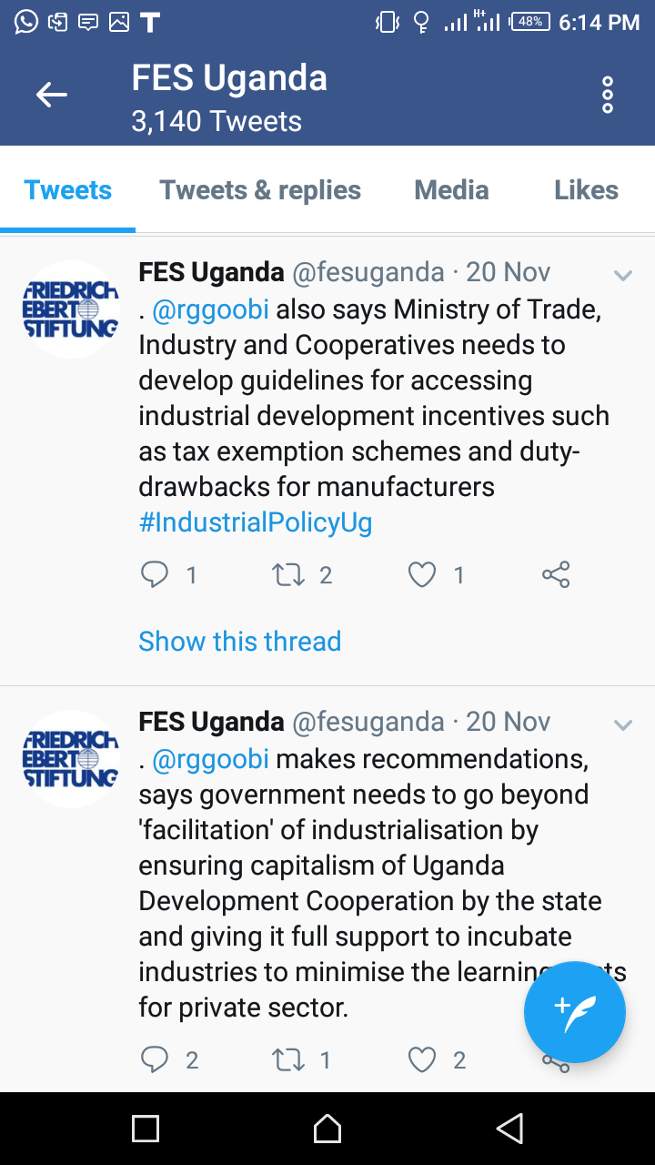
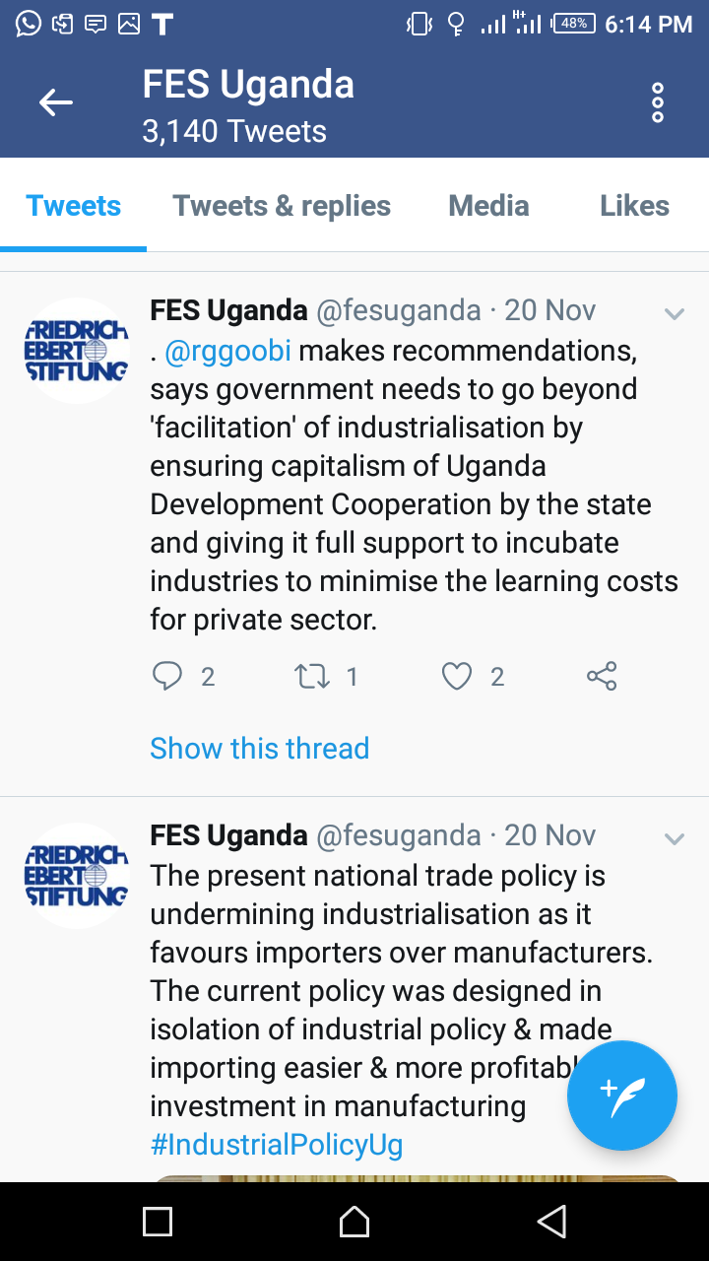
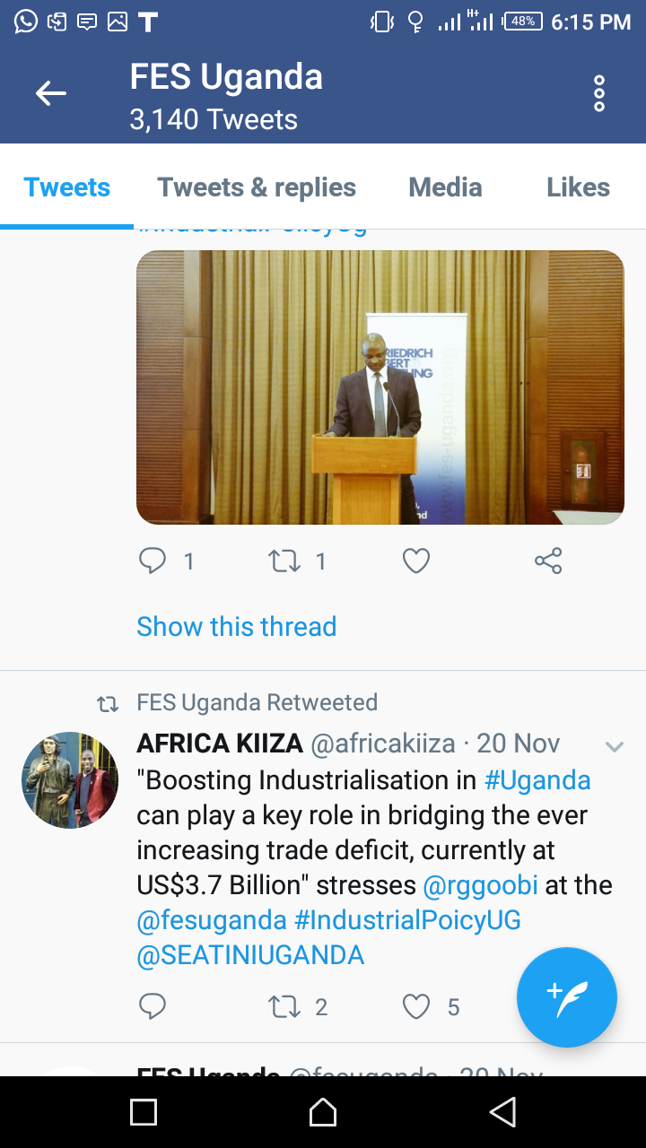
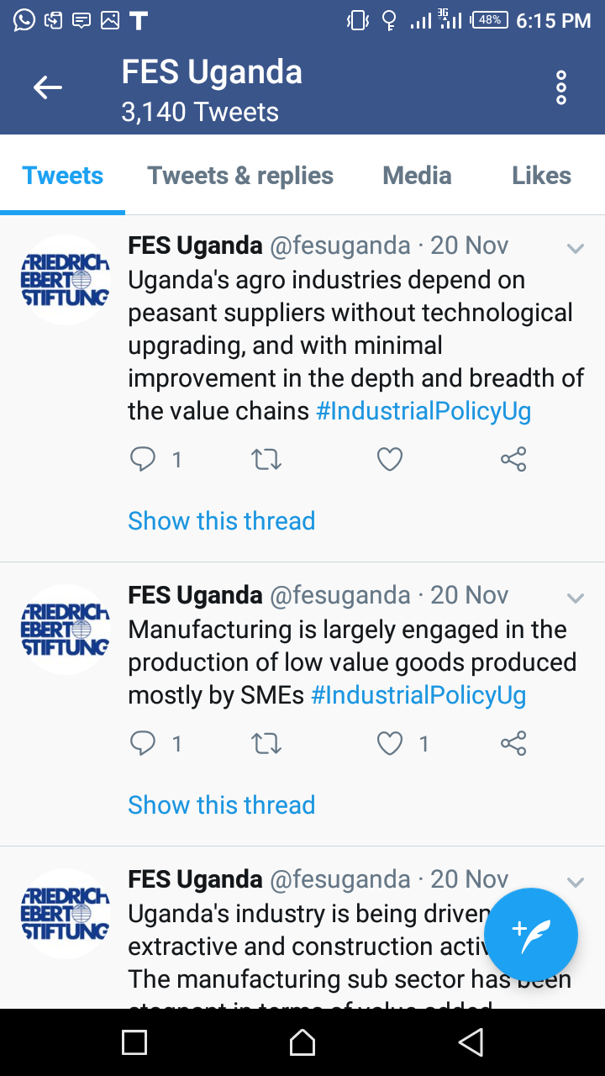
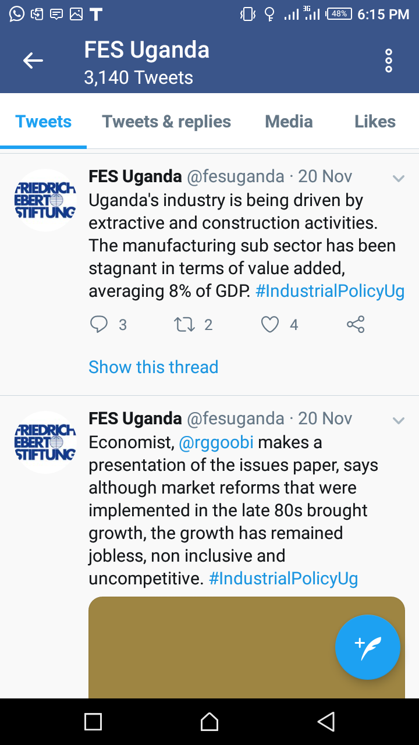

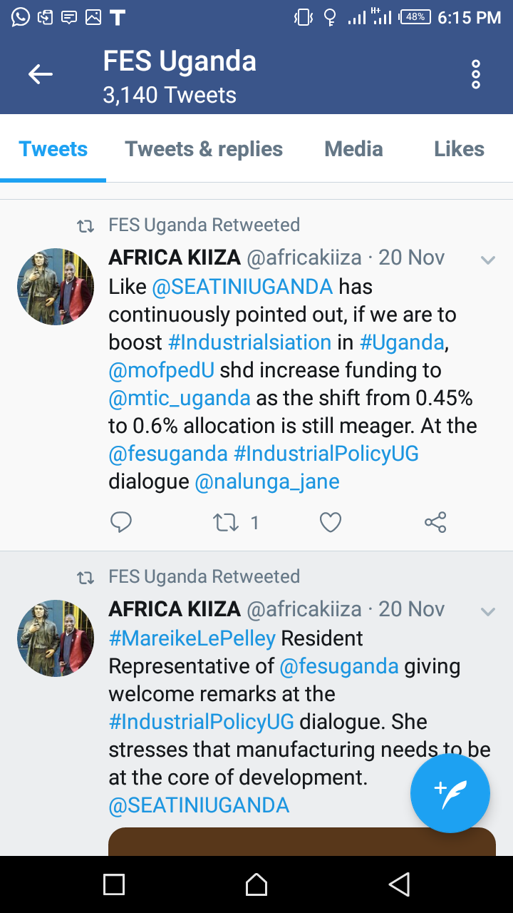
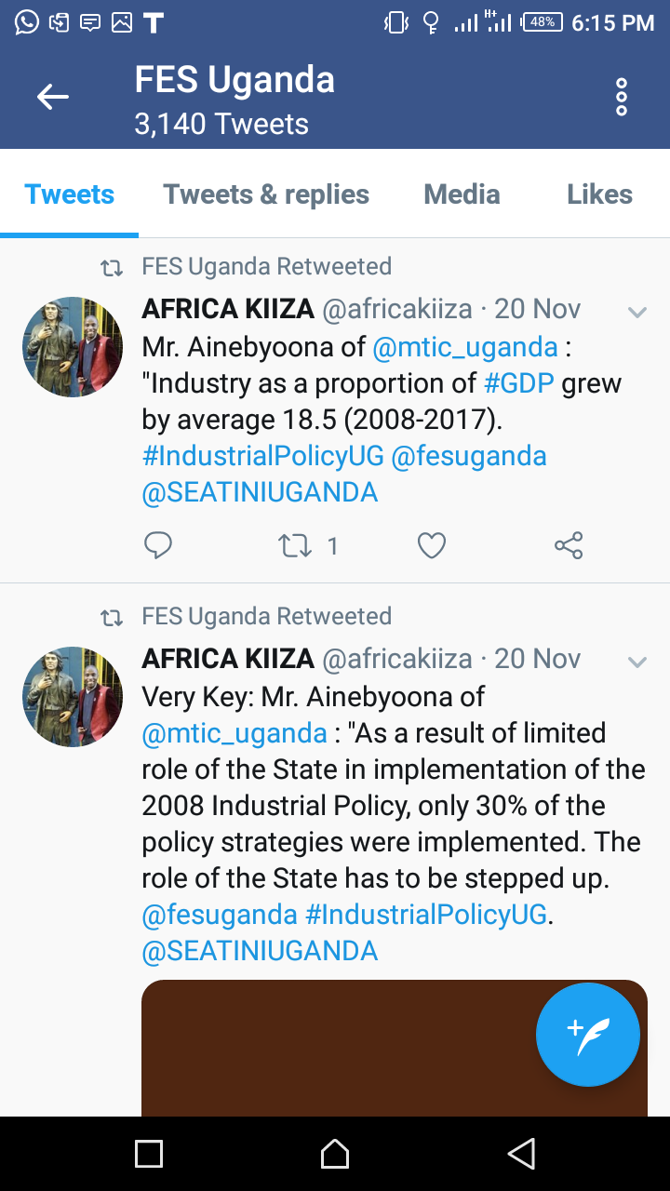
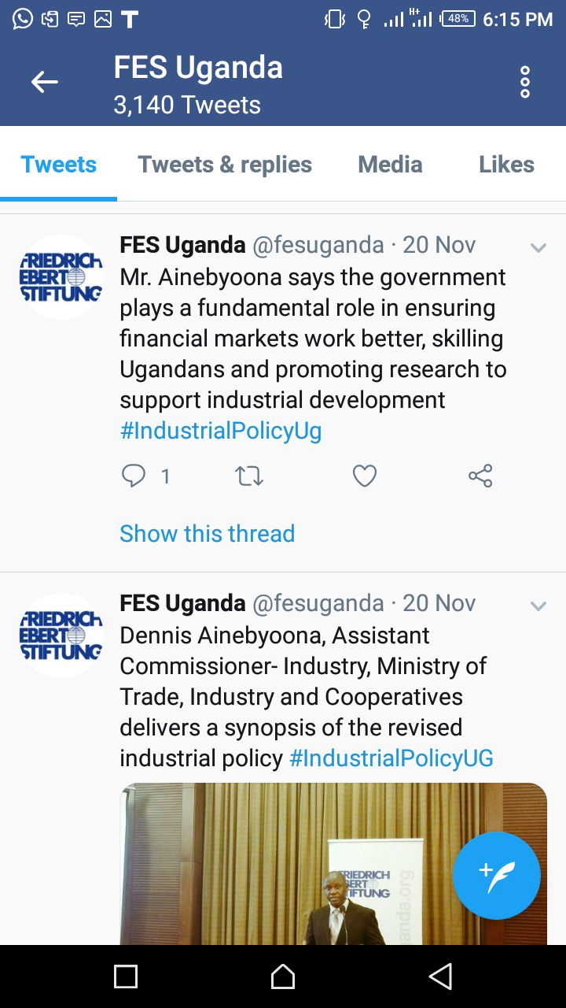
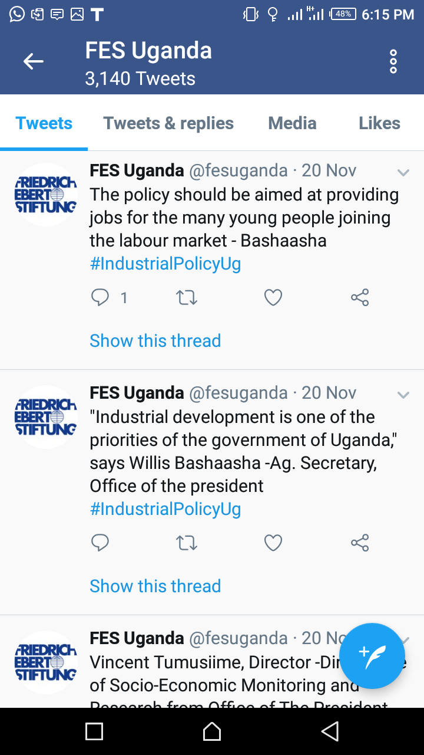
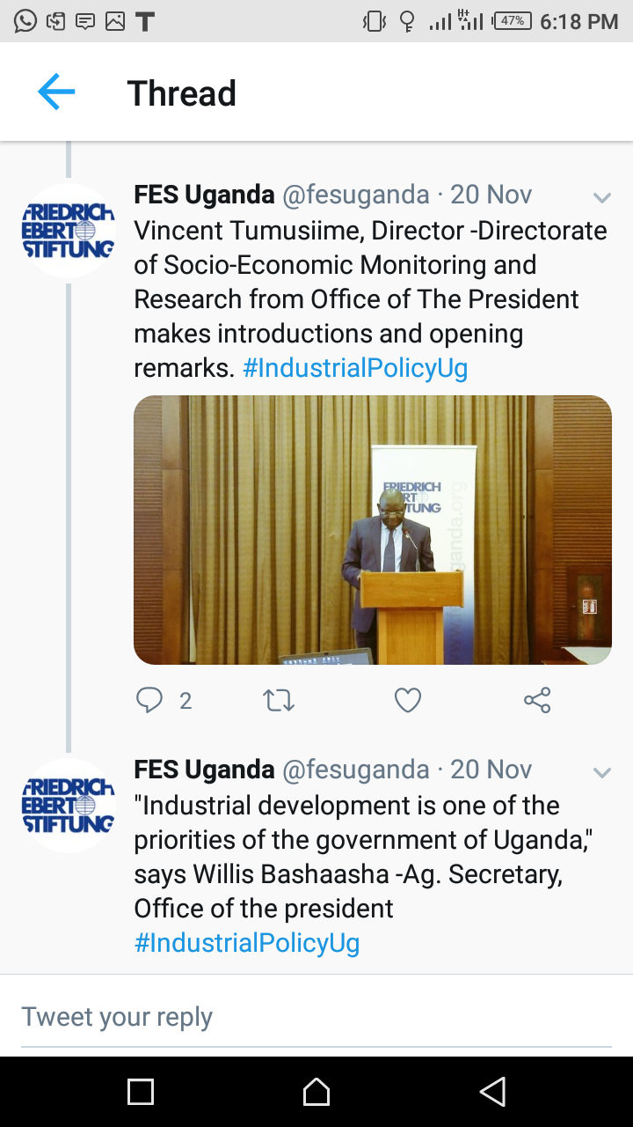
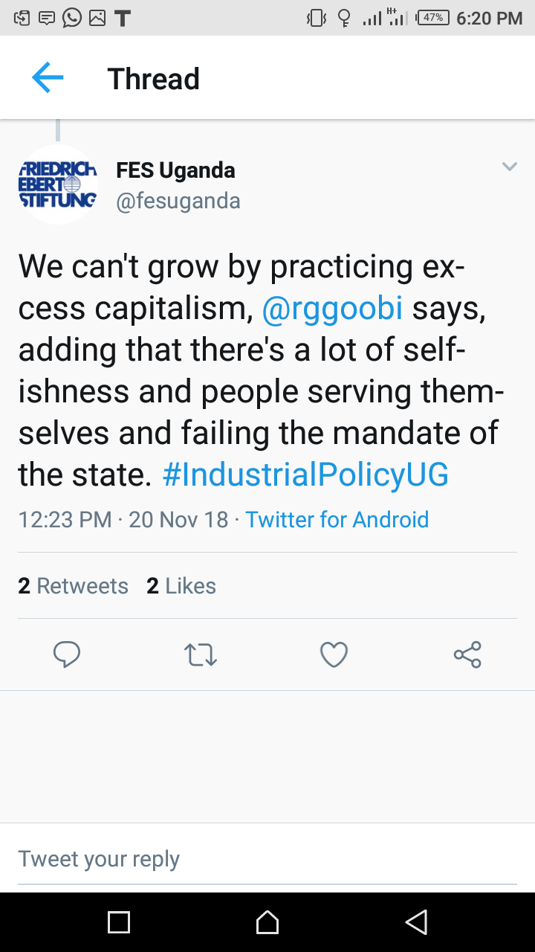
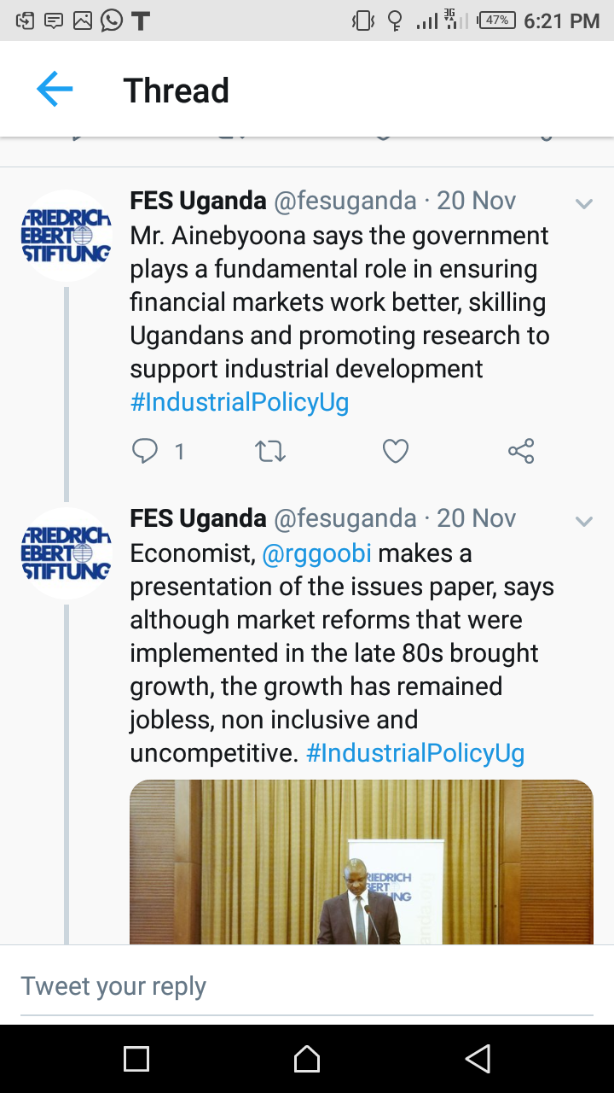
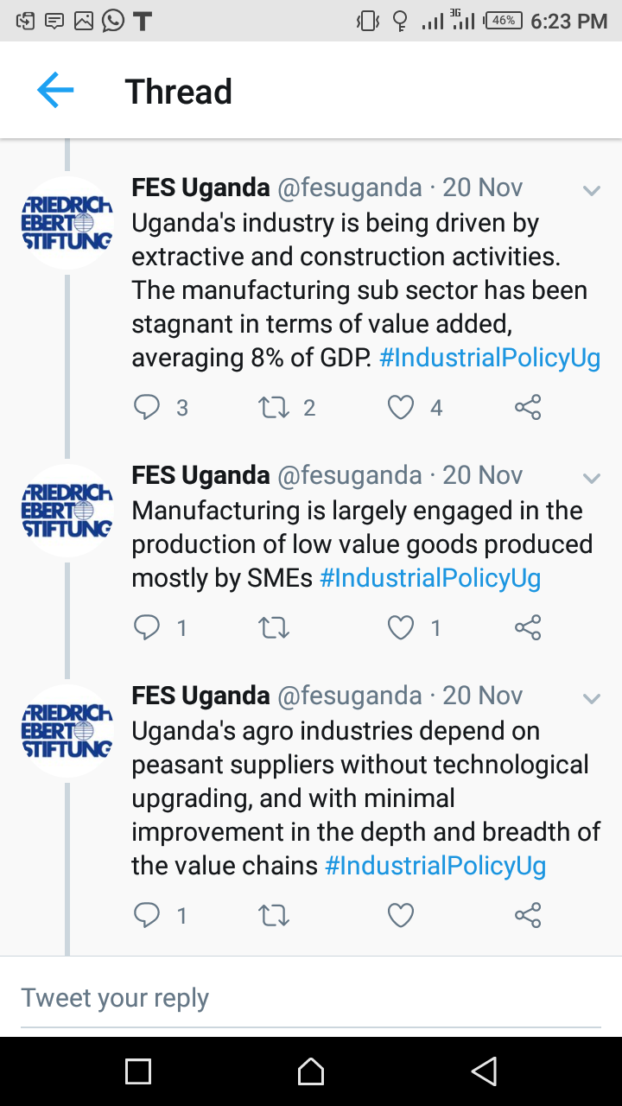
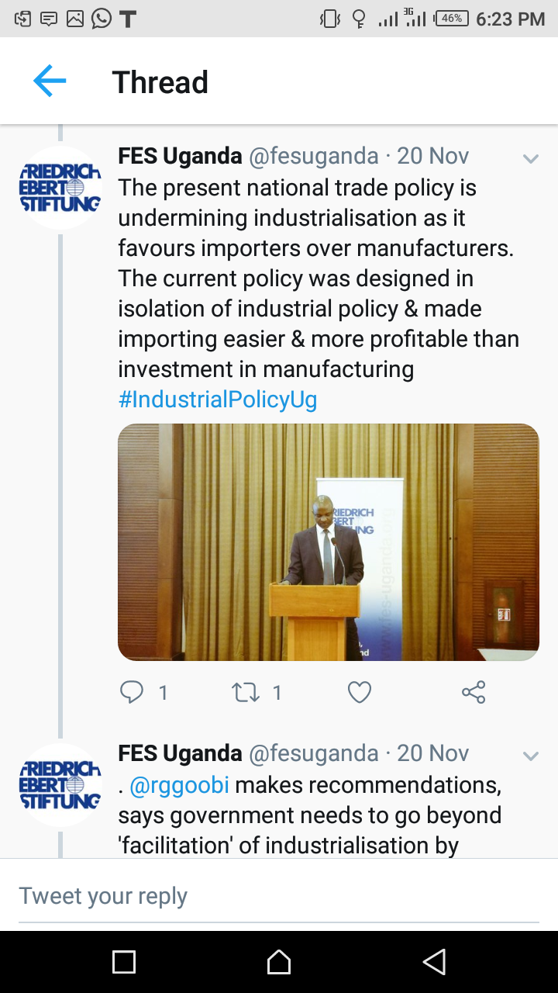
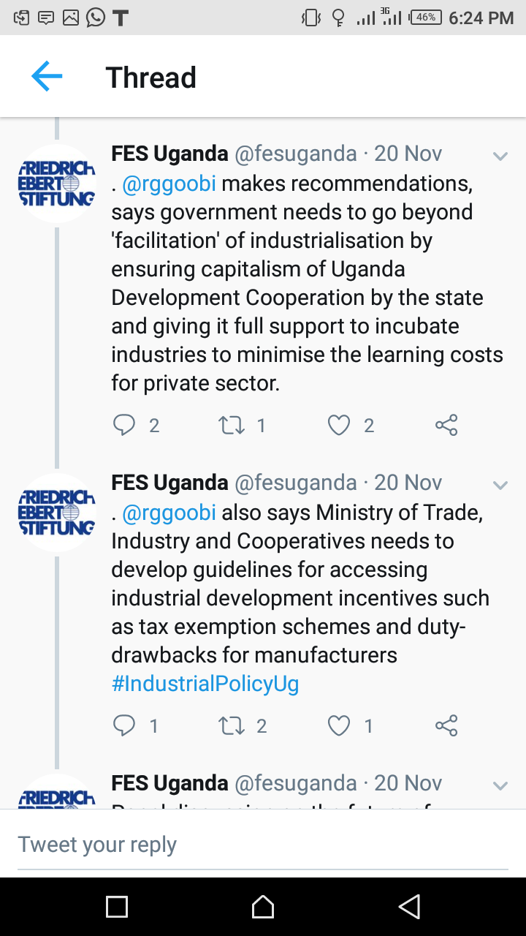
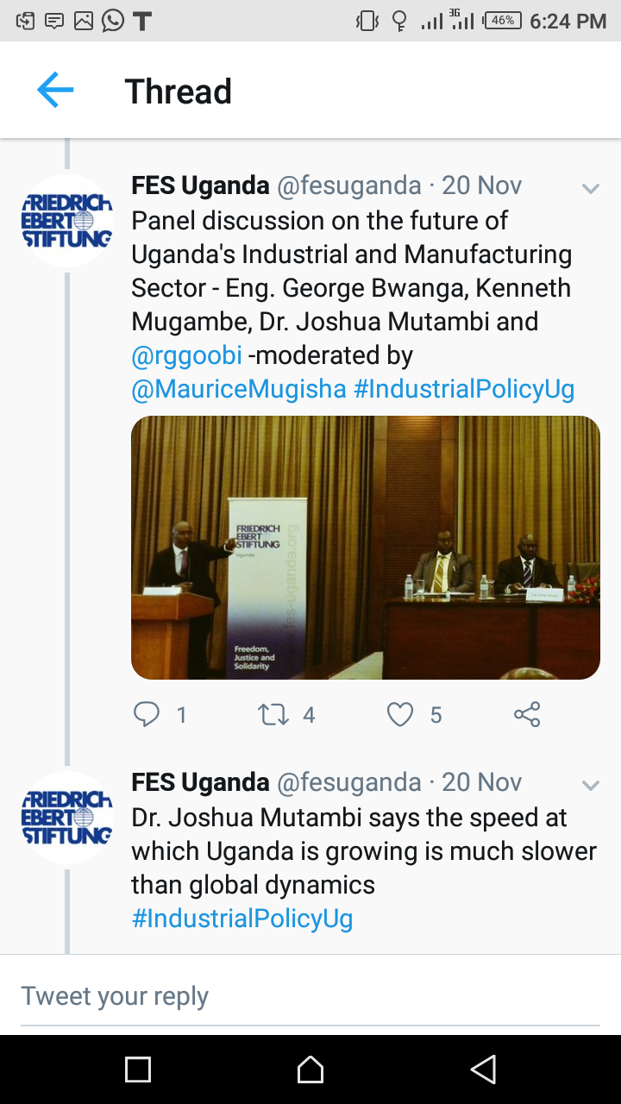
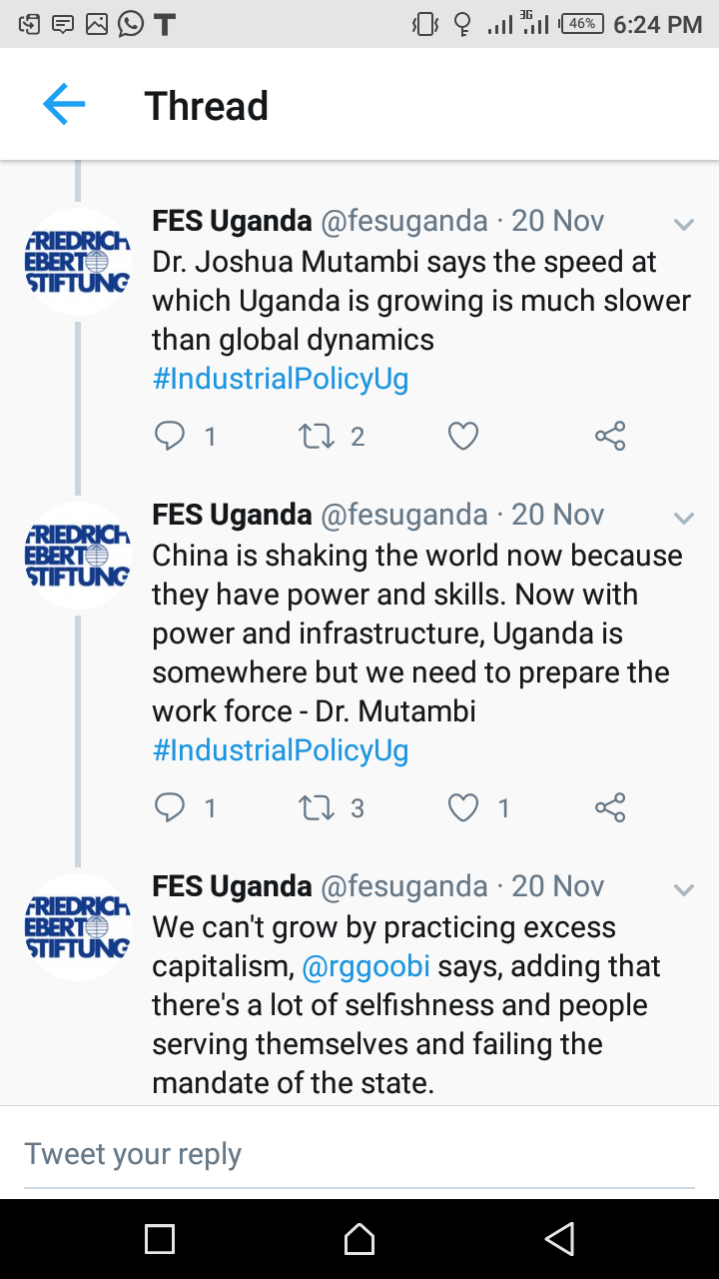
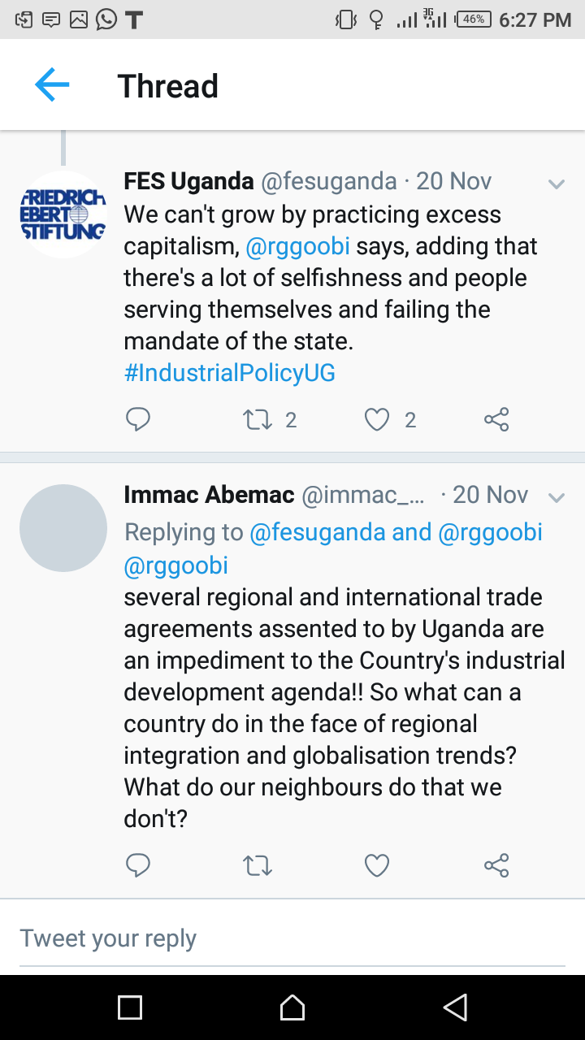

2.7 Closing remarks
The concluding remarks was given by the Director-Directorate of Socio-economic Monitoring and Reseach, Office of the President. He thanked all members for their active participation and contributions. He assured them that the Office of the President would ensure that all the agree upon position of the members in regards to the revised industrial policy are taken up by MTIC before submitting the revised version of the Industrial policy to Cabinet. He also said that a team of technical Officers would be constituted after the meeting and a mini meeting would be held so as to identify which recommendations are actionable and thus forwarded to MTIC. He then presented to the members a summary of the issues identified in the industrial policy and the agreed positions of the members as far as recommendations are concerned.
Summary of key issues from the plenary discussions
S/N | Issue Identified | Specific Areas of Interest | Responsible MDAs
1 | Getting the State pro-actively Involved in Industrialization. | - Re-Capitalization of UDC  - Supporting Incubation of Industries  - Decision Criterion for State Support to Industries.  - Affordable capital for Industrialization | OP, OPM , MTIC, UIA, MoFPED, PSF (U), UDC UDB and Resource people (Prof. Ngobi and Prof. Julius from Makerere University)
2 | Harmonizing the National Industrial Development Policy with other related policies | Ensure harmony with policies related to:  - Training, skills and technology development.  - Infrastructure Development.  - Agriculture and Environment  - Financial Sector  - Occupational safety  Standards  - Investment Land policy.  - Investment Code | NPA, MoES, MEMD, MAAIF, NEMA, MGLSD, UNBS, MLHUD, UIA, OP(Cabinet Secretariat), Uganda Insurers Association (UIA) , OPM  and Resource People.
3 | Ensuring the Macro-Economic Framework is conducive for the Industrialization Agenda | - Exchange Rate Stability  - Inflation | B.o.U, EPRC, UMA, OPM, OP and Resource People.
4 | Harmonization of the Industrialization Master plan and industrial Policy | Study the two frameworks and harmonize | MTIC, NPA, OPM, OP and Resource People.
5 | Regulation | Legislate and enforce competition and anti-trust laws for promotion and regulation of competition in the private sector. | UMA, MOJCA, PSFU, MTIC OPM, OP and Resource Persons.
6 | Collaboration between Academia and Practitioners | Development of a mechanism to link practitioners and academia for evidenced based decision making | UIRI, EPRC, MUK (College of Engineering, Design, Art and Technology), MTIC, OP and Resource people.
7 | Lack of effective policy co-ordination in government , weak leadership in Public Policy Management , Corruption and Poor policy implementation | Separate and differentiate roles and responsibility of the key players in Public Policy Management | OP, NPA, OPM as well as Resource Personnel
8 | Emphasis on Local Content and making provisions for the protection of Local investors in Uganda | Explore the possibility of policy protection provisions for local investors against low end investors. | MTIC, OP (Cabinet Secretariat), NPA, OPM, UMA, PSFU and Resource Personnel.
9 | Harmonization of Trade Policy Descent employment policy, skills development and the Industrial | Studying areas of convergence and ensuring that the industrial policy provides for descent jobs and is consistence with the employment policy under review. | MTIC, MOE&S, NPA, OPM, OP and Ministry of Gender  as well as Resource Personnel
10 | Review of key National Policies that facilitate operationalization of Industrial policy. | Taking stock of key policies that need review. | NPA, MTIC, PSFU, MoFPED, Cabinet Secretariats, OPM, and OP as well as Resource Personnel.
11 | Legislate and enforce competition and anti-trust laws | Analyze and assess the possibility of incorporation | MTIC, NPA, Attorney General’s Office, OP and OPM as well as Resource Personnel.

3.0 Concluding remarks

The concluding remarks was given by Hon. Dr. Kasirivu Atwooki, the Minister for Economic Affairs. He thanked all the members for coming to attend the meeting and also for actively participating throughout the entire dialogue. He re-assured the members that the Office of the President is taking the leadership role in policy making. He said all members are welcome to join hands to work together with the Presidency to ensure that effective policies are designed.

He informed members that the Office of the President has designed a platform code named “APEX” that will play a vital role in policy management and improve policies, projects and programs. He said this Platform has already been approved by Cabinet and is due to be operational/functional in FY 2019/2020.

He once again thanked members for honoring the invites to the meeting, and thereafter wished them a nice afternoon and a safe journey back home. He then declared the meeting officially closed!

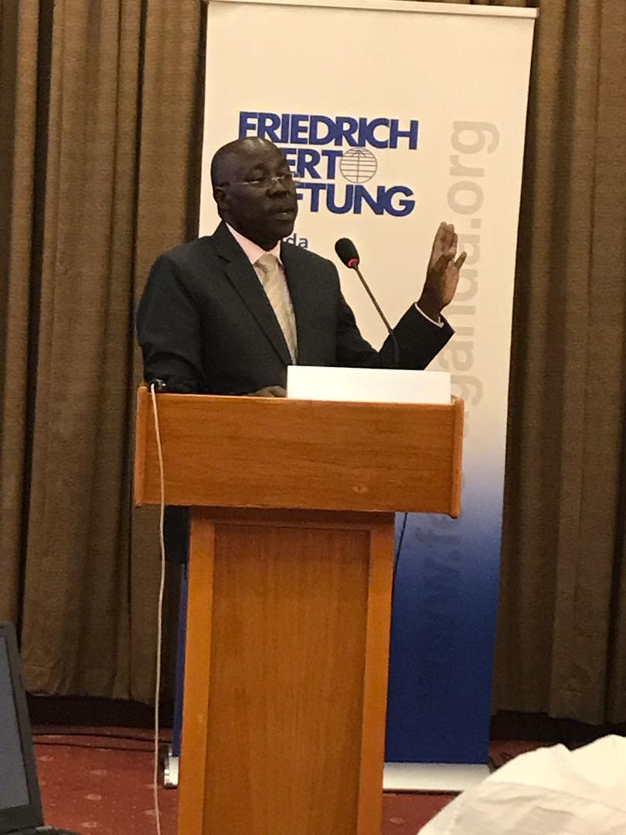
Figure 6 Hon. Dr. Kasirivu Atwooki, the Minister for Economic Affairs giving the closing remarks.

